APPENDIX D: Open Method Architecture Skill (v4.1)
Refined Method-Open Skill Architecture & Three Executed Empirical Demonstrations:
(1) UTD24 Journal Submission Replication, (2) Independent (Non-UTD24 Submission) QCA-Only, and (3) Best-Fit Multi-Method Analysis
Date: 2026-10-30 | Package: Open_Method_Architecture_Skill_Package.zip | Verification: 17/17 Core Invariants Passed | Status: Work in Progress (Provisional Research Prototype)
Work-in-Progress & Epistemic Governance Statement
The Open Method Architecture Skill (v4.1) refines QCMA Skill v4.0 to align fully with the method-open architecture in the Organization Science Stage 1 proposal (Unbounding Theory Elaboration) and incorporates all methodological and software audit improvements identified during review:
1. Method Selection as an Explicit Outcome of Synthesis: Construct and relational coding (Skills 01–02) remain method-neutral until Skill 03 (evaluate_method_fit) diagnoses the corpus structure and routes to QCA, Process-Sequence modeling, Multi-Dimensional Regime Clustering, Hybrid Triangulation, or Qualitative Synthesis.
2. Production-Time Artifact Lineage (produced_from) & Mandatory Prerequisites: Every derived matrix, truth table, and sequence model records the SHA-256 hashes of the exact upstream artifacts used when it was computed. Issuing a new approval packet after an upstream change cannot launder an un-recomputed artifact.
3. Orthogonal Aggregation vs. Missingness Rules: Theoretical operators (min, mean, max) are strictly separated from incomplete-evidence policies (complete_component_required, boolean_absorption_available, available_component_fallback, null_to_zero_imputation, null_to_one_stress).
4. Genuine Raw-to-Solution Re-Execution: All three demonstrations in this report are recomputed from raw/source matrices by control/run_three_demos.py using control/oma_engines.py (never replayed from static strings).

About this appendix
In simple terms
This appendix explains how the Open Method Architecture skill package is used to compare findings from published studies about AI and knowledge work. The package helps organize evidence, compare interpretations and examine what changes when researchers make different analytical choices. Its purpose is to support researcher judgment—not to replace it or automatically prove a theory.
The appendix brings together three demonstrations and two supporting detailed reports:
- Demonstration 1 revisits the existing AI-integration analysis. It examines whether reported results can be reproduced and how they change when coding, missing evidence, case boundaries or analytical settings are handled differently.
- Demonstration 2 asks a different question about expert authority and uses QCA to examine combinations of conditions. QCA—Qualitative Comparative Analysis—compares how conditions work together rather than estimating one average effect at a time.
- Demonstration 3 examines whether a combination of methods can offer a fuller explanation. It separates decision authority from renewal of professional knowledge practices and adds sequence-based and statistical comparisons to the configurational analysis.

How the appendix is organized
Part I provides the main overview and comparison of the three demonstrations. Part II contains an earlier, more detailed QCMA replication report. Part III contains a separate detailed analysis of expert authority, followed by its evidence ledger, truth tables, study-exclusion checks and execution record. These are distinct analysis records: their case counts, outcome labels and coding choices should not be treated as interchangeable.

How to read it
For a quick understanding, start with Part I and its final synthesis. For the technical decisions behind the replication, use Part II. For the independent authority analysis and its source-level supporting material, use Part III. The table of contents links directly to each main section; the Navigation Pane in Word also shows the subsection headings.

What the results mean—and do not mean
The document presents the reported operation and outputs of a provisional research prototype. Reproducing a calculation is different from validating its source coding, approving an interpretation or establishing a causal mechanism. Read the limitations, sensitivity checks and decisions pending researcher review alongside the results. This introduction and table of contents do not constitute a new verification of the analyses.

Table of contents
Click a section title to jump to it (Ctrl+click in some Word views). Page numbers can be generated by right-clicking the table and choosing Update Field → Update entire table. They are not estimated in this copy.
5 1
1. Overview of the Open Method Architecture & Three Demonstrations 5
2. Demonstration 1: Replication & Sensitivity Audit of the UTD24 Journal Submission Analysis 6
3. Demonstration 2: Independent (Non-UTD24 Submission) QCA-Only Analysis (DEC_AUTH) 7
4. Demonstration 3: Method-Open Best-Fit Hybrid Analysis (Recommended by Skill 03) 8
5. Synthesis Across All Three Demonstrations: Theory Elaboration Register & Next Steps 11
Part II. Earlier QCMA replication: detailed supporting report 12
Executive Summary 12
Stage 1: Corpus Intake and Case Boundary Reconciliation (G1_cases) 13
Stage 2: Construct Operationalization and Dual-Coder Evidence Audit (G2A_codebook & G2B_coding) 14
Stage 3: Cross-Study Theoretical Translation and Interpretive Branching (G3_translation) 16
Stage 4: Deterministic Calibration and Multi-Branch fsQCA Results (G4_qca_spec & G5_qca_verified) 17
Stage 5: Configurational Theory, Reverse Evidence Lineage, and Adversarial Critique (G6_theory_release) 21
Part III. Independent expert-authority QCMA: detailed supporting report 28
1. Findings brief 29
2. Purpose, independence from the UTD24 manuscript, and scope 30
3. Workflow followed and checkpoint record 30
4. Corpus intake and screening 31
5. Case registry 32
6. Construct discovery and codebook 33
7. Cross-study translation and method-fit assessment 34
8. Calibration, coding matrix and missingness policy 35
9. Results 36
10. Robustness, scope checks and interpretive branches 39
11. Configurational theory elaboration 40
12. Limitations (claim-specific) 41
13. Better or complementary empirical strategies (ranked) 42
14. Decisions pending researcher review 42
Appendix A. Evidence ledger (page-located anchors) 43
Appendix B. Full truth table for EAR (all 32 configurations) 44
Appendix C. Leave-one-study-out results 45
Appendix D. Reproducibility and execution record 45
References (supplied corpus, with DOIs as printed in the files) 45

Part I. Overview and comparison of the three demonstrations

1. Overview of the Open Method Architecture & Three Demonstrations
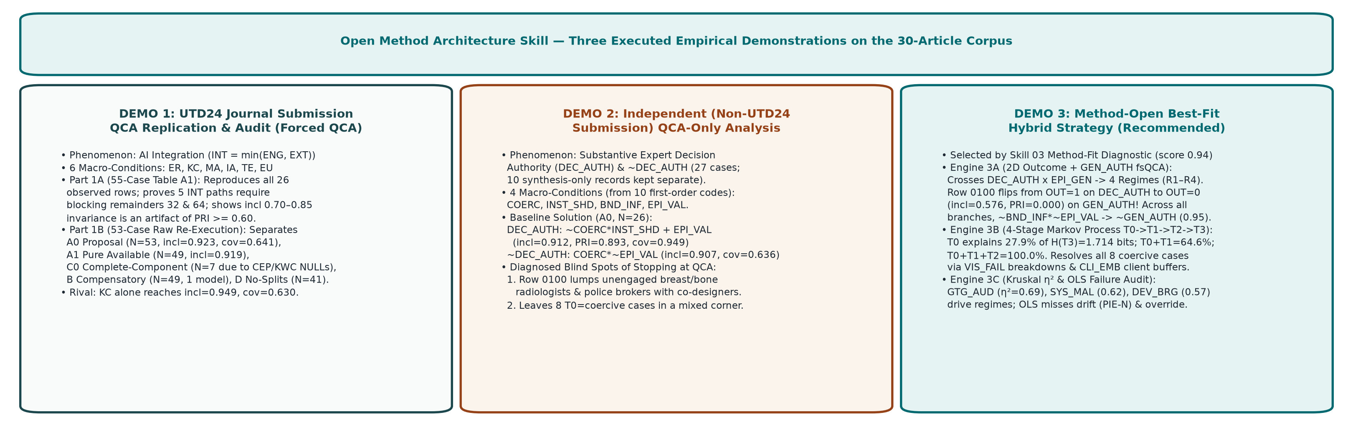
Figure 1. Side-by-side comparison of the three empirical demonstrations executed by control/run_three_demos.py.
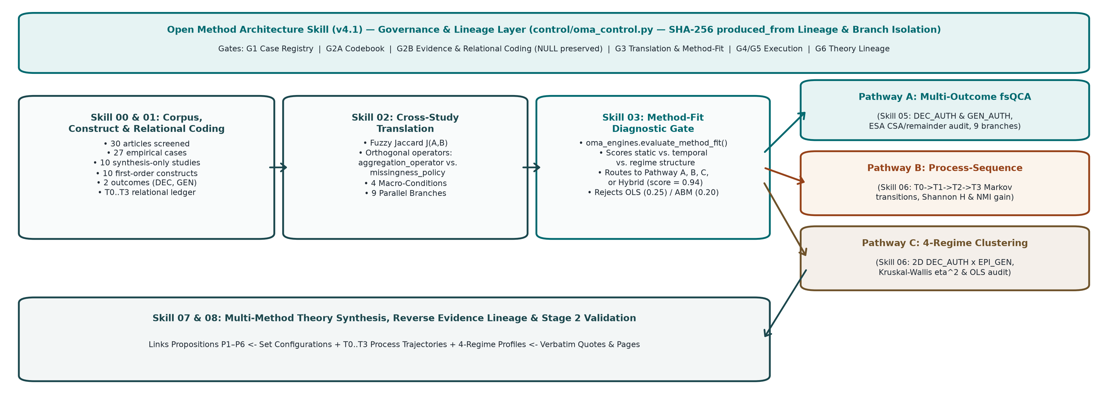
Figure 2. Architecture of the Open Method Architecture Skill showing the Synthesis Layer, Method-Fit Diagnostic Gate, and Three Analytical Pathways.
Audit Issue Identified in Review | Refinement Implemented in Open Method Architecture Skill (v4.1) | Verified in Code & Tests
Defaulting to QCA as the only analytical destination | Added Skill 03 (03_method_fit_and_routing.md) & oma_engines.evaluate_method_fit(), plus Skill 06 (Markov Process-Sequence & 2D Regime Kruskal–Wallis / OLS Audit). Theory synthesis (Skill 07) accepts verified outputs from any pathway. | Test 10 & 17 in run_oma_checks.py; Demo 3
Case intake Component 0 included inside core loop | Converted into 00_optional_case_intake_adapter.md, disabled by default (intake_adapter_enabled=False). Researcher-approved cases and locatable excerpts are the standard entry contract. | Tests 1 & 2 in run_oma_checks.py
Ambiguous NULL representation ('None / 0') and bundled Branch C | Raw coding strictly uses None/NaN for NULL (never 0). Translation rules require separate aggregation_operator and missingness_policy fields. | Test 5 in run_oma_checks.py; Demo 1B C0 vs. A1 vs. A0 vs. C1
Packet hashes could approve an old un-recomputed derived artifact after upstream edits | Added production-time lineage (produced_from: {parent: sha256}) to every artifact and recursive artifact_lineage_is_fresh() verification. | Tests 6, 7 & 13 in run_oma_checks.py
Caller-selected required_artifacts & simulated human actor | Enforced built-in MANDATORY_PREREQS per task and separated execution_mode ('researcher_operated', 'scripted_demo', 'computational_replay'). | Tests 3, 4 & 8 in run_oma_checks.py
Demo runner replayed stored JSON strings; silent maxk=10 cover cap | Rewrote control/run_three_demos.py to recompute all three demos from raw cell scores and Table A1 rows; removed silent maxk cap in cover_solutions(). | Executed in control/run_three_demos.py

2. Demonstration 1: Replication & Sensitivity Audit of the UTD24 Journal Submission Analysis
In Demonstration 1, the Open Method Architecture Skill is instructed to replicate and stress-test the UTD24 Journal submission AI-integration fsQCA (Outcome: Engaged & Extensive AI Integration INT = min(ENG, EXT); 6 macro-conditions: External Receptivity ER, Knowledge Congruence KC, Mandated Automation MA, Inexperienced Augmentation IA, Transitional Ease TE, and Epistemic Uncertainty EU). We execute both Part 1A (the 55-case, 64-row aggregate truth table from Appendix Table A1) and Part 1B (raw cell-by-cell recomputation of the 53-case 30-article dual-coder dataset).

2.1 Part 1A: Exact 55-Case / 64-Row Table A1 Reproduction & Remainder Audit
- Verified Truth-Table Properties: 64 rows total; 26 observed rows (55 cases) and 38 empty logical remainders (59.4% limited diversity). Exactly 18 observed rows (32 cases) pass incl >= 0.80 and PRI >= 0.60 for INT; 3 observed rows (rows 5, 6, 38; 13 cases) pass for ~INT; and 5 observed rows (rows 3, 7, 19, 46, 62; 10 cases, 18.2% of N) pass neither outcome because their PRI falls between 0.452 and 0.598.
- Standard vs. ESA Remainder-Excluded Intermediate Solution: Under directional expectation KC = 1 with all easy counterfactuals permitted, standard Quine–McCluskey minimization yields: KC*~MA*IA*~EU + ER*IA*TE + ER*MA*~EU + MA*~TE*~EU + MA*IA*TE*EU (where Path 2 is MA*IA*TE*EU and Path 3 is ER*IA*TE). Blocking empty remainder rows 32 (0,1,1,1,1,1) and 64 (1,1,1,1,1,1) under Enhanced Standard Analysis (ESA) reproduces the exact 5 pathways reported in the UTD24 Journal submission: KC*~MA*IA*~EU + ER*MA*~EU + ER*~MA*IA*TE + MA*~TE*~EU + ~KC*MA*IA*TE*EU.
- Reproduced Non-Integration (~INT) Solution: Conservative minimization of rows 5, 6, and 38 reproduces the exact 2 reported non-integration pathways: ~KC*~MA*IA*~TE*EU + ~ER*~KC*~MA*IA*~TE.
UTD24 Path | Assemblage Name in UTD24 Submission | Reproduced Boolean Term | Truth-Table Rows Covered | Reproduced Raw Cases (n) | Reported Fit (incl / PRI / cov / ucov)
Path 1a | Decreed Acquiescence | ER*MA*~EU | 41, 43, 45, 47, 59, 61, 63 | 11 | 0.849 / 0.673 / 0.381 / 0.025
Path 1b | Decreed Acquiescence | MA*~TE*~EU | 9, 13, 41, 45, 61 | 9 | 0.829 / 0.625 / 0.362 / 0.027
Path 2 | Decreed Reconstitution | ~KC*MA*IA*TE*EU | 16, 48 (requires blocking rem. 32 & 64) | 4 | 0.949 / 0.822 / 0.181 / 0.032
Path 3 | Selective Consultation | ER*~MA*IA*TE | 39, 40, 55, 56 (requires blocking rem. 64) | 6 | 0.919 / 0.788 / 0.337 / 0.058
Path 4 | Cooperative Reinforcement | KC*~MA*IA*~EU | 21, 23, 53, 55 | 9 | 0.974 / 0.941 / 0.366 / 0.102
~INT 5a | Non-Integration 5a | ~ER*~KC*~MA*IA*~TE | 5, 6 | 7 | 0.883 / 0.728 / 0.492 / 0.154
~INT 5b | Non-Integration 5b | ~KC*~MA*IA*~TE*EU | 6, 38 | 11 | 0.814 / 0.663 / 0.361 / 0.023

Table A1 Threshold Sensitivity Audit (Why incl = 0.70–0.85 Cannot Fail):
Threshold Specification | Pos. Rows | Models | Resulting Intermediate Solution Formula
Baseline (incl>=0.80, PRI>=0.60, n>=1) | 18 | 1 | KC*~MA*IA*~EU + ER*MA*~EU + ER*~MA*IA*TE + MA*~TE*~EU + ~KC*MA*IA*TE*EU
incl>=0.70, PRI>=0.60, n>=1 | 18 | 1 | KC*~MA*IA*~EU + ER*MA*~EU + ER*~MA*IA*TE + MA*~TE*~EU + ~KC*MA*IA*TE*EU
incl>=0.75, PRI>=0.60, n>=1 | 18 | 1 | KC*~MA*IA*~EU + ER*MA*~EU + ER*~MA*IA*TE + MA*~TE*~EU + ~KC*MA*IA*TE*EU
incl>=0.85, PRI>=0.60, n>=1 | 18 | 1 | KC*~MA*IA*~EU + ER*MA*~EU + ER*~MA*IA*TE + MA*~TE*~EU + ~KC*MA*IA*TE*EU
incl>=0.90 (weak), PRI>=0.60, n>=1 | 17 | 1 | KC*~MA*IA*~EU + ER*~MA*IA*TE*EU + ER*MA*~EU + MA*~TE*~EU + ~KC*MA*IA*TE*EU
incl>0.90 (strict), PRI>=0.60, n>=1 | 16 | 1 | KC*~MA*IA*~EU + ER*MA*~EU + MA*~TE*~EU + ER*KC*~MA*IA*TE + ~KC*MA*IA*TE*EU
incl>=0.80, PRI>=0.50, n>=1 | 20 | 1 | KC*~MA*IA*~EU + ER*MA*~EU + ER*~MA*IA*TE + ER*MA*IA*~TE + MA*~TE*~EU + ~KC*MA*IA*TE*EU
incl>=0.80, PRI>=0.70, n>=1 | 16 | 1 | KC*~MA*IA*~EU + ER*~MA*IA*TE*EU + ER*MA*~EU + ~KC*MA*IA*TE*EU + MA*IA*~TE*~EU
incl>=0.80, PRI>=0.60, n>=2 (drop singletons) | 10 | 1 | ~ER*~KC*MA*IA*TE*EU + KC*~MA*IA*~TE*~EU + ~ER*KC*~MA*IA*~EU + ER*~MA*IA*TE + ER*MA*~TE*~EU + ER*KC*MA*~IA*TE*~EU + MA*IA*~TE*~EU

2.2 Part 1B: Raw-to-Solution Re-Execution of the 53-Case / 30-Article Dual-Coder Dataset
When we recompute the 53-case 30-article dataset directly from the 954 raw cell scores in demonstration/utd24_53_attached_raw.json (rather than replaying stored result strings), separating Theoretical Aggregation from Incomplete-Evidence Handling exposes a major methodological finding:
Branch & Missingness Policy | N | Pos. Rows | Models | INT Fit  (incl / PRI / cov) | ~INT Fit  (incl / PRI / cov) | KC-Alone Rival  (incl / PRI / cov) | First Intermediate Model Formula
A0: Proposal Macro-Zero (N=53) | 53 | 11 | 6 | 0.923 / 0.748 / 0.641 | 0.835 / 0.668 / 0.746 | 0.949 / 0.841 / 0.630 | ~ER*KC*MA*TE*EU + ~ER*KC*IA*TE*EU + ER*KC*MA*~IA*TE + ER*KC*~MA*IA*TE + ER*KC*~MA*TE*EU + ~ER*MA*TE*~EU + ~ER*MA*IA*~EU
A1: Pure Available (N=49) | 49 | 11 | 6 | 0.919 / 0.733 / 0.643 | 0.834 / 0.649 / 0.643 | 0.947 / 0.831 / 0.643 | ~ER*KC*MA*TE*EU + ~ER*KC*IA*TE*EU + ER*KC*MA*~IA*TE + ER*KC*~MA*IA*TE + ER*KC*~MA*TE*EU + ~ER*MA*TE*~EU + ~ER*MA*IA*~EU
B: Compensatory Mean (N=49) | 49 | 9 | 1 | 0.916 / 0.658 / 0.480 | 0.857 / 0.723 / 0.750 | 0.898 / 0.720 / 0.684 | ~ER*MA*IA*TE + ~ER*~KC*MA*IA*EU + MA*~IA*TE*EU + ER*KC*MA*~IA*TE
C0: Complete-Component (N=7) | 7 | 3 | 1 | 1.000 / 1.000 / 0.631 | 1.000 / 1.000 / 0.514 | 0.874 / 0.668 / 0.501 | ~ER*MA*~IA*TE*~EU + ~ER*MA*IA*~TE*~EU
C1: NULL->0.0 Imputed (N=53) | 53 | 4 | 1 | 0.930 / 0.700 / 0.373 | 0.843 / 0.692 / 0.753 | 0.920 / 0.772 / 0.258 | ~ER*MA*~IA*TE*~EU + ~ER*KC*~MA*TE*~EU + ER*KC*MA*~IA*TE*~EU
D: No Splits (N=41) | 41 | 11 | 1 | 0.917 / 0.708 / 0.619 | 0.872 / 0.725 / 0.639 | 0.956 / 0.852 / 0.636 | ER*KC*MA*~IA*TE + ER*KC*~MA*IA*TE + ER*MA*IA*TE*EU + ~ER*KC*TE*EU + ~ER*MA*IA*~EU
Coder 1: Claude Opus 4.6 (N=53) | 53 | 5 | 1 | 0.959 / 0.775 / 0.509 | 0.869 / 0.707 / 0.794 | 0.947 / 0.787 / 0.614 | KC*~MA*IA*TE*EU + ~ER*KC*IA*TE*EU + ER*KC*MA*IA*TE*~EU + ER*KC*MA*~IA*TE*EU
Coder 2: GPT-4.1 (N=33) | 33 | 8 | 1 | 0.937 / 0.840 / 0.614 | 0.809 / 0.666 / 0.602 | 0.781 / 0.479 / 0.646 | ER*KC*~MA*IA*TE*EU + ~ER*KC*MA*TE*EU + ~KC*MA*~IA*TE*~EU + ER*KC*MA*~IA*~TE*EU + ER*~KC*MA*~IA*TE + ~ER*MA*IA*~TE*EU

Three critical insights from Table 2.2: (1) Complete-Component Attrition (N=7): Because Client Evaluation Pressure (CEP) is NULL in 26/53 cases and Know-What Congruence (KWC) is NULL in 25/53 cases, requiring every constituent of all 6 macro-conditions to be non-null leaves only 7 complete cases! (2) Available-Component without Macro Zero-Fill (N=49) vs. Macro Zero-Fill (N=53): Using available constituents without zero-filling leaves 4 cases with an all-NULL macro-condition (N=49, incl=0.919, PRI=0.733, cov=0.643); filling those 4 remaining macro-level NaNs with 0.0 reproduces the exact proposal baseline (N=53, incl=0.923, PRI=0.748, cov=0.641). (3) Single-Condition Rival: Across every branch, Knowledge Congruence (KC) alone achieves incl = 0.946–0.949 and cov = 0.625–0.630, matching the full 6-condition model's coverage.

3. Demonstration 2: Independent (Non-UTD24 Submission) QCA-Only Analysis (DEC_AUTH)
In Demonstration 2, we analyze the 30 supplied articles without replicating the UTD24 Journal submission, restricting the tool to a pure QCA pathway (Skill 05). We ask an independent research question: Under which combinations of sociotechnical conditions do domain experts retain or reconstruct Substantive Decision Authority over AI-mediated judgments (DEC_AUTH), and under which combinations is that decision authority displaced (~DEC_AUTH)?
- Corpus Reconciliation (30 Articles → 20 Empirical Case Articles [27 Cases] + 10 Synthesis-Only Records): Ten articles lack a bounded post-deployment case (Cruz 2024; Dutta & Naveen 2025; Ergün et al. 2026; Goto 2021, 2022, 2023; Hopf et al. 2025; Kellogg et al. 2025; Pemer & Werr 2025; Vuori et al. 2025) and are held in the Conceptual & Field-Level Register. Eight within-paper subgroup splits (EIN-D/T, FAU-A/L, PIE-S/N, VDB-HR/LM) are flagged and tested by exclusion in Branch D.
- Bottom-Up First-Order Constructs & Fuzzy Jaccard Translation: Ten first-order constructs (ALG_SUB, MGT_CTRL, PROF_JUR, CLI_EMB, DEV_BRG, MED_BRK, GTG_AUD, SYS_MAL, EPI_OPA, VIS_FAIL) were coded on the 1–5 rubric (with LI's unreported MGT_CTRL preserved as NULL) and translated via Fuzzy Jaccard similarity (Figure 3) into four macro-conditions: Coercive Algorithmic Closure (COERC), Institutional & Relational Standing (INST_SHD), Boundary & Malleable Infrastructure (BND_INF), and Active Epistemic Interrogation (EPI_VAL).
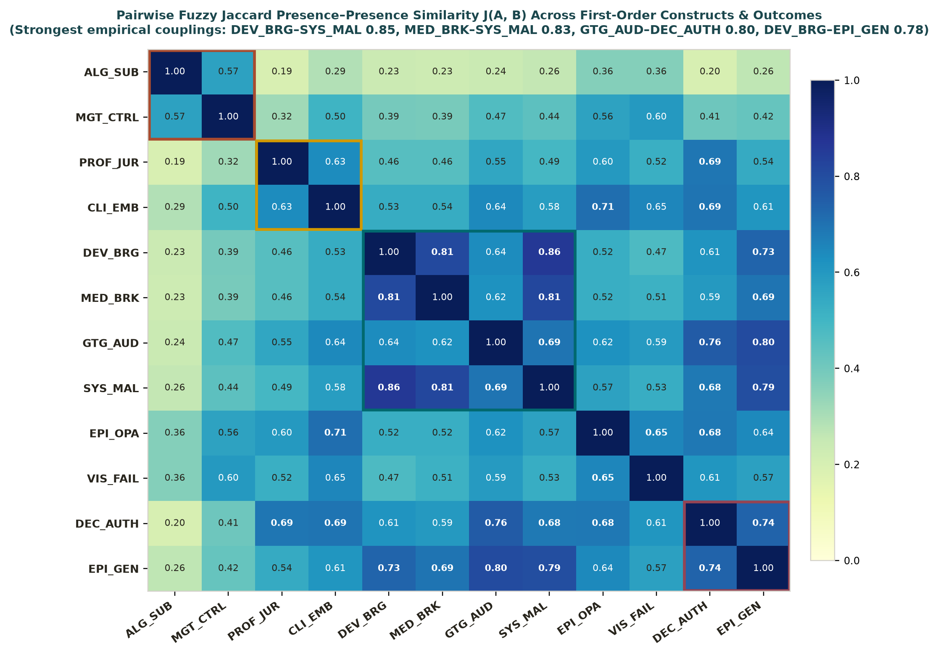
Figure 3. Pairwise Fuzzy Jaccard similarity J(A, B) across the 10 independent first-order constructs and 2 outcome dimensions.
Branch Specification | N | DEC_AUTH Intermediate Formula | DEC_AUTH Fit  (incl / PRI / cov) | ~DEC_AUTH Intermediate Formula | ~DEC_AUTH Fit  (incl / PRI / cov)
A0_complete_N26 | 26 | ~COERC*INST_SHD + EPI_VAL | 0.912 / 0.893 / 0.949 | COERC*~EPI_VAL | 0.907 / 0.860 / 0.636
A1_avail_N27 | 27 | ~COERC*INST_SHD + EPI_VAL | 0.916 / 0.899 / 0.952 | COERC*~EPI_VAL | 0.907 / 0.860 / 0.636
B_compensatory | 27 | ~COERC + EPI_VAL + INST_SHD | 0.877 / 0.853 / 0.936 | COERC*~INST_SHD*~EPI_VAL | 0.791 / 0.618 / 0.648
C1_null_zero | 27 | ~COERC*INST_SHD + EPI_VAL | 0.916 / 0.899 / 0.952 | COERC*~EPI_VAL | 0.907 / 0.860 / 0.636
C2_null_one | 27 | ~COERC*INST_SHD + EPI_VAL | 0.916 / 0.899 / 0.952 | COERC*~EPI_VAL | 0.907 / 0.860 / 0.636
D_nosplits | 18 | EPI_VAL + ~COERC*INST_SHD | 0.909 / 0.891 / 0.944 | COERC*~EPI_VAL | 0.935 / 0.911 / 0.671
E_jur_only | 26 | EPI_VAL + ~COERC*INST_SHD | 0.935 / 0.921 / 0.936 | ~INST_SHD*~EPI_VAL | 0.831 / 0.739 / 0.799
F_logistic | 26 | ~COERC*INST_SHD + EPI_VAL | 0.915 / 0.897 / 0.964 | COERC*~EPI_VAL | 0.928 / 0.884 / 0.699
G_direct | 26 | ~COERC*INST_SHD + EPI_VAL | 0.915 / 0.899 / 0.958 | COERC*~EPI_VAL | 0.918 / 0.881 / 0.643

What Demonstration 2 (QCA-Only) Finds—and the 3 Structural Blind Spots It Cannot Resolve
• What QCA-Only Finds: Across 8 of 9 branches (and all 19 Leave-One-Study-Out drops), Substantive Decision Authority (DEC_AUTH) is explained by ~COERC*INST_SHD + EPI_VAL (incl = 0.909–0.935, PRI = 0.891–0.921, cov = 0.936–0.964), while displacement (~DEC_AUTH) is explained by COERC*~EPI_VAL (incl = 0.907–0.935, cov = 0.636–0.701) or ~INST_SHD*~EPI_VAL (in Pure-Licensure Branch E, cov = 0.799).
• Blind Spot 1 (Conflated High-Authority Regimes): Truth-table Row 0100 (~COERC*INST_SHD*~BND_INF*~EPI_VAL) has incl = 0.910 and OUT = 1 on DEC_AUTH, lumping unengaged radiologists who ignored AI claims (LEB-BREAST, LEB-BONE) and police brokers who monopolized an opaque algorithm (WAA) into the same 'success' set as engaged co-designers!
• Blind Spot 2 (Unresolved Coercive-Entry Bifurcation): Eight cases enter under high coercive substitution (ALG_SUB >= 4, MGT_CTRL >= 4, PROF_JUR <= 2), yet split across GIA-DSL (retained/co-evolved), EIN-T & GIA-RM (supervisory override), MAY-BIO & MAY-REC (client-facing reconstruction), and STR-BANK, MON, VDB-LM (displaced). Static QCA cannot see the temporal sequence of operational breakdowns (VIS_FAIL) and client mobilization (CLI_EMB) that separates them.
• Blind Spot 3 (Exclusion of 10 Conceptual/Field Studies): Static QCA has no formal way to integrate the 10 non-case studies without inventing case rows.

4. Demonstration 3: Method-Open Best-Fit Hybrid Analysis (Recommended by Skill 03)
In Demonstration 3, the Open Method Architecture Skill activates Skill 03 (oma_engines.evaluate_method_fit) before choosing an analytical engine. Because 16 of 27 empirical cases are longitudinal/ethnographic studies (59.3%), DEC_AUTH has an 81.5% positive skew, and authority exhibits two distinct dimensions (decision control vs. epistemic practice renewal), Skill 03 scores Static QCA Alone at 0.68 ('Defensible but Incomplete'), rejects Additive Linear OLS (0.25) and unparameterized ABM (0.20), and selects the Hybrid Multi-Method Triangulation Strategy (fit score = 0.94).

4.1 Engine 3A: 2D Outcome Disaggregation (DEC_AUTH × EPI_GEN) & Multi-Outcome GEN_AUTH fsQCA
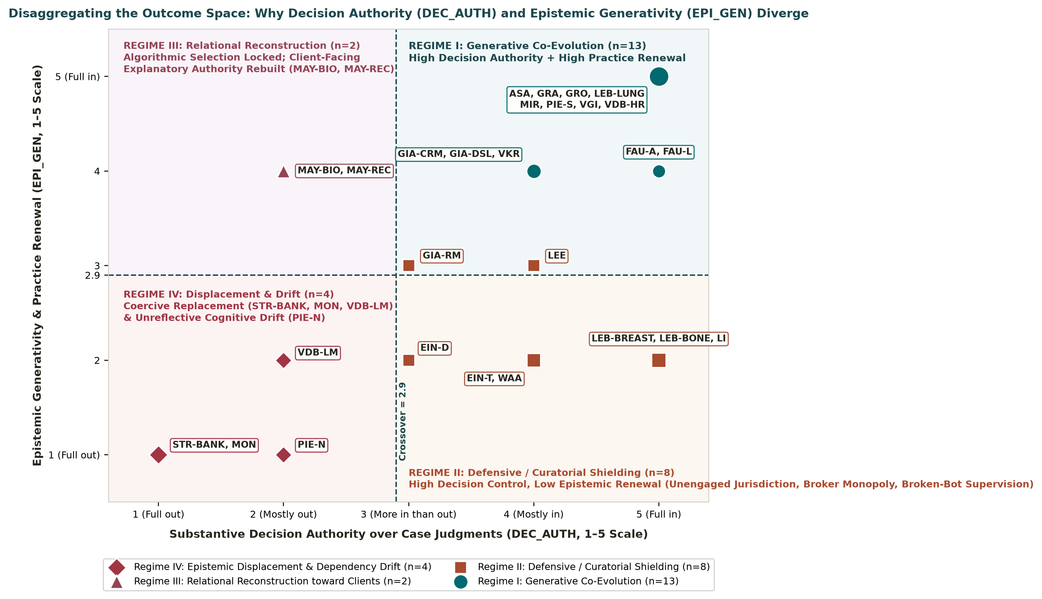
Figure 4. Disaggregating Substantive Decision Authority (DEC_AUTH) and Epistemic Generativity (EPI_GEN) into Four Regimes across the 27 cases.
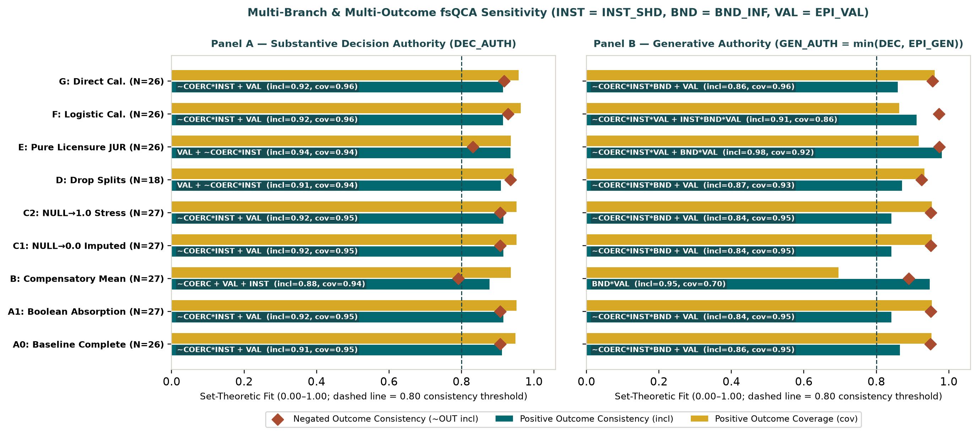
Figure 5. Multi-outcome and multi-branch fsQCA comparison showing how tightening the outcome from DEC_AUTH (Panel A) to GEN_AUTH (Panel B) eliminates passive jurisdictional shielding.
Branch Specification | ESA CSAs Excluded | GEN_AUTH Intermediate Formula | GEN_AUTH Fit  (incl / PRI / cov) | ~GEN_AUTH Intermediate Formula | ~GEN_AUTH Fit  (incl / PRI / cov)
A0_complete_N26 | None | ~COERC*INST_SHD*BND_INF + EPI_VAL | 0.865 / 0.817 / 0.952 | ~BND_INF*~EPI_VAL | 0.949 / 0.921 / 0.798
A1_avail_N27 | None | ~COERC*INST_SHD*BND_INF + EPI_VAL | 0.842 / 0.785 / 0.953 | ~BND_INF*~EPI_VAL | 0.950 / 0.921 / 0.768
B_compensatory | 1010, 1110 | BND_INF*EPI_VAL | 0.947 / 0.924 / 0.696 | COERC*~BND_INF*~EPI_VAL | 0.890 / 0.793 / 0.474
C1_null_zero | None | ~COERC*INST_SHD*BND_INF + EPI_VAL | 0.842 / 0.785 / 0.953 | ~BND_INF*~EPI_VAL | 0.950 / 0.921 / 0.768
C2_null_one | None | ~COERC*INST_SHD*BND_INF + EPI_VAL | 0.842 / 0.785 / 0.953 | ~BND_INF*~EPI_VAL | 0.950 / 0.921 / 0.768
D_nosplits | None | ~COERC*INST_SHD*BND_INF + EPI_VAL | 0.871 / 0.825 / 0.933 | ~BND_INF*~EPI_VAL | 0.925 / 0.890 / 0.800
E_jur_only | None | ~COERC*INST_SHD*EPI_VAL + BND_INF*EPI_VAL | 0.981 / 0.974 / 0.917 | ~COERC*~INST_SHD*~BND_INF + ~BND_INF*~EPI_VAL | 0.974 / 0.957 / 0.797
F_logistic | None | ~COERC*INST_SHD*EPI_VAL + INST_SHD*BND_INF*EPI_VAL | 0.911 / 0.880 / 0.863 | ~BND_INF*~EPI_VAL | 0.973 / 0.960 / 0.783
G_direct | None | ~COERC*INST_SHD*BND_INF + EPI_VAL | 0.859 / 0.818 / 0.961 | ~BND_INF*~EPI_VAL | 0.955 / 0.932 / 0.778

Why Engine 3A Solves Blind Spot 1: When the outcome requires both decision authority and epistemic renewal (GEN_AUTH = min(DEC_AUTH, EPI_GEN)), truth-table Row 0100 (~COERC*INST_SHD*~BND_INF*~EPI_VAL: LEB-BREAST, LEB-BONE, WAA) drops from incl = 0.910, PRI = 0.862 (OUT = 1) on DEC_AUTH to incl = 0.576, PRI = 0.000 (OUT = 0) on GEN_AUTH! Passive institutional standing without boundary bridging or active interrogation protects formal veto power (Regime II), but never produces generative human–AI co-evolution (Regime I). Across all branches, ~BND_INF*~EPI_VAL is sufficient for ~GEN_AUTH (incl = 0.925–0.974, PRI = 0.890–0.960).

4.2 Engine 3B: Four-Stage Markov Process-Sequence & Shannon/NMI Information-Gain Analysis
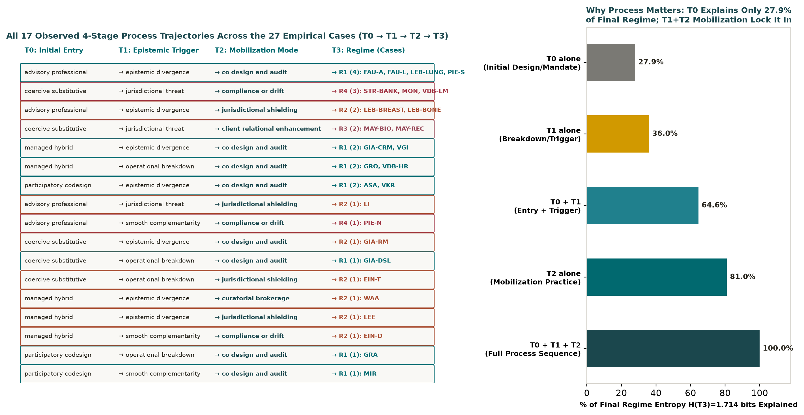
Figure 6. Left: All 17 observed 4-stage process trajectories (T0 → T1 → T2 → T3). Right: Cumulative percentage of final regime entropy H(T3)=1.714 bits explained at each temporal stage.
Why Engine 3B Solves Blind Spot 2 (The 8-Case Coercive-Substitutive Bifurcation): Initial deployment structure T0 explains only 27.9% of final regime entropy (MI = 0.477 bits out of H(T3) = 1.714 bits). Adding the T1 epistemic trigger (operational_breakdown, epistemic_divergence, jurisdictional_threat, smooth_complementarity) doubles explained information to 64.6% (MI = 1.108 bits), and T2 mobilization practices lock in 100.0% (MI = 1.714 bits). Among the 8 cases entering at T0 = coercive_substitutive, visible operational failure (VIS_FAIL = 5) with reachable internal developers triggers hypothesis-testing co-design (GIA-DSL → Regime I); failure with unreachable developers triggers supervisory override without co-design (EIN-T, GIA-RM → Regime II); high client embeddedness (CLI_EMB = 5) shifts authority reconstruction to client explanations (MAY-BIO, MAY-REC → Regime III); and locked systems with transactional client contact lock in displacement (STR-BANK, MON, VDB-LM → Regime IV).

4.3 Engine 3C: Four-Regime Kruskal–Wallis Discriminant Analysis & Additive OLS Failure Audit
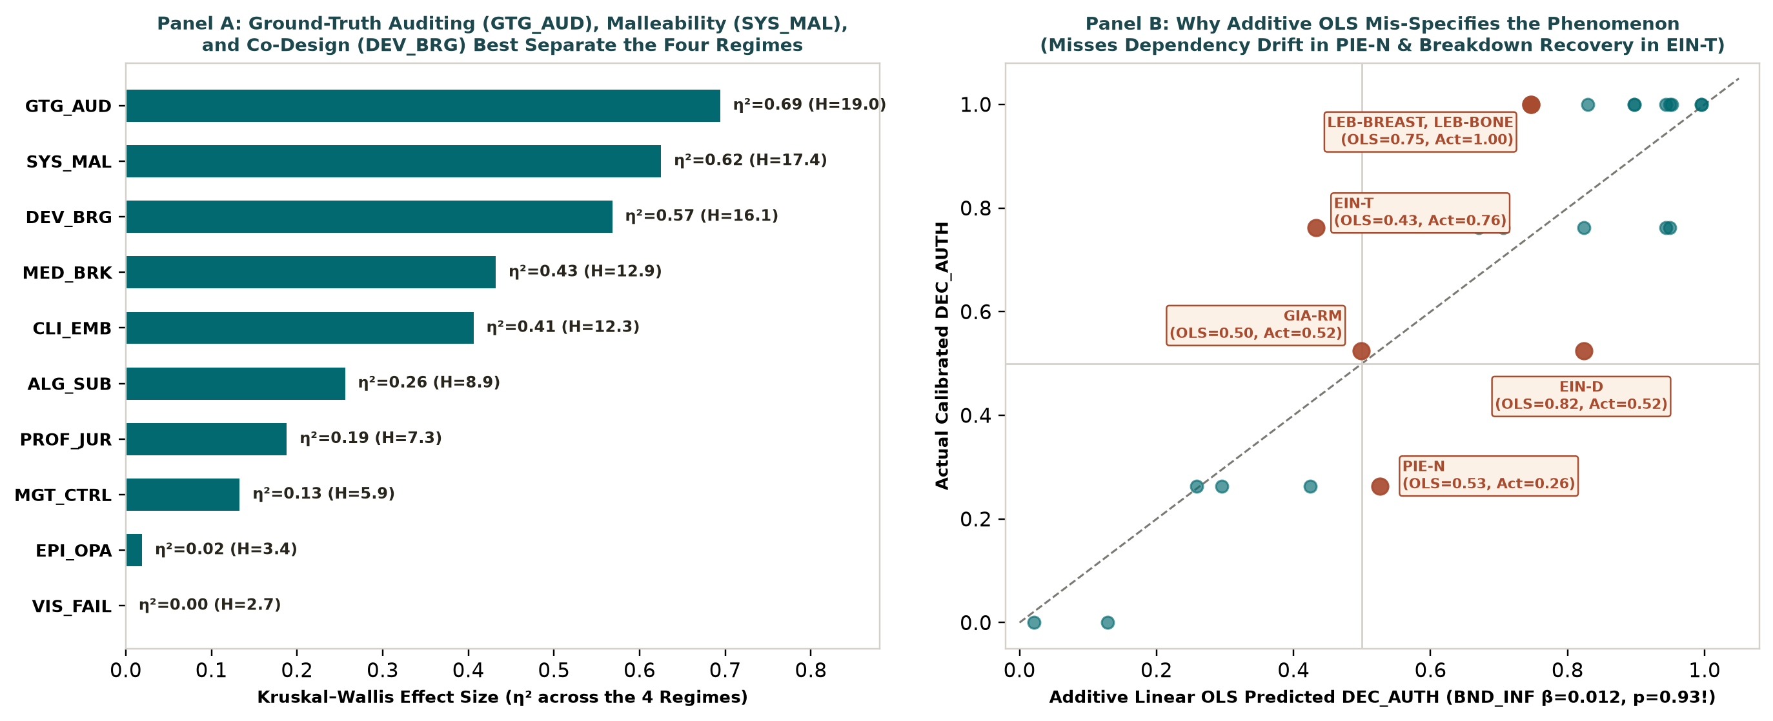
Figure 7. Panel A: Non-parametric Kruskal–Wallis effect sizes (η²) across the four regimes. Panel B: Additive OLS predicted vs. actual DEC_AUTH showing crossover sign errors.
Why Engine 3C Outperforms Variance Regression: Non-parametric Kruskal–Wallis tests across the four regimes prove that active socio-technical practices—Ground-Truth Auditing (GTG_AUD, H=18.97, η²=0.694), Technical Malleability (SYS_MAL, H=17.38, η²=0.625), Developer Co-Design (DEV_BRG, H=16.06, η²=0.568), Brokerage (MED_BRK, η²=0.432), and Client Embeddedness (CLI_EMB, η²=0.406)—discriminate regimes far more powerfully than Algorithmic Substitution (ALG_SUB, η²=0.256), Professional Jurisdiction (PROF_JUR, η²=0.193), or Managerial Control (MGT_CTRL, η²=0.130), while Experienced Opacity (EPI_OPA, η²=0.019) is a near-constant scope condition. By contrast, an additive OLS regression estimates the net effect of Boundary Infrastructure (BND_INF) on DEC_AUTH as β = +0.012 (t = 0.09, p = 0.93) and commits crossover sign errors on PIE-N (predicting 0.527 vs. actual 0.263, missing cognitive dependency drift), EIN-T (predicting 0.432 vs. actual 0.762, missing breakdown recovery), GIA-RM (predicting 0.499 vs. actual 0.524), and EIN-D on GEN_AUTH (predicting 0.631 vs. actual 0.263).

5. Synthesis Across All Three Demonstrations: Theory Elaboration Register & Next Steps
Prop. ID | Elaboration Type | Core Theoretical Proposition | Multi-Method Empirical Signature (Demo 2 vs. Demo 3) | Synthesis-Only Field Corroboration (10 Studies) | Survival Status
P1 | Outcome Disaggregation & Boundary Specification | Institutional jurisdiction under low coercion (~COERC*INST_SHD) preserves formal decision veto (DEC_AUTH), but without boundary infrastructure or active interrogation (~BND_INF*~EPI_VAL) it yields Defensive Shielding (Regime II) rather than Generative Co-Evolution (Regime I). | Row 0100 flips from OUT=1 (incl=0.910) on DEC_AUTH to OUT=0 (incl=0.576, PRI=0.000) on GEN_AUTH; ~BND_INF*~EPI_VAL -> ~GEN_AUTH (incl=0.949). | Goto (2021, 2022) & Pemer & Werr (2025) on protective professional jurisdiction. | Invariant across all 9 branches & 19 LOSO drops.
P2 | Mechanism Refinement | Generative human–AI co-evolution (GEN_AUTH, Regime I) requires coupling active ground-truth interrogation (EPI_VAL) with socio-technical boundary infrastructure (BND_INF: co-design, brokerage, malleability; Jaccard J=0.81–0.86) or non-coercive institutional standing. | Branch E GEN_AUTH: ~COERC*INST_SHD*EPI_VAL + BND_INF*EPI_VAL (incl=0.981, PRI=0.974); Kruskal η²: GTG_AUD=0.694, SYS_MAL=0.625, DEV_BRG=0.568. | Hopf et al. (2025) (hybrid group mind) & Ergün et al. (2026) (leader coaching). | Core invariant across all branches.
P3 | Temporal Relationship Revision | Coercive, substitutive deployment (T0 = coercive_substitutive) is not sufficient for displacement: visible operational breakdowns (T1 = VIS_FAIL) act as epistemic shocks that trigger generative re-looping when internal developers are reachable (GIA-DSL → R1) or supervisory override when they are not (EIN-T, GIA-RM → R2). | Process NMI: T0 explains 27.9% of H(T3); T0+T1 explains 64.6%; T0+T1+T2 explains 100.0%. | Fernandez Cruz (2024) on error-triggered intervention. | Invisible to static QCA; 100% resolved by Pathway B.
P4 | Lateral Locus Shift | When algorithmic selection is locked (ALG_SUB=5, DEC_AUTH=2) and no technical breakdown forces redesign, high client relational embeddedness (CLI_EMB=5) enables experts to reconstruct authority laterally toward clients (MAY-BIO, MAY-REC → Regime III). | Kruskal CLI_EMB mean = 5.00 in R3 vs. 2.25 in R4; separating CLI_EMB in Branch E raises GEN_AUTH incl from 0.865 to 0.981. | Dutta & Naveen (2025) on consultative HR repositioning. | Explicitly isolated by Branch E & Pathway C.
P5 | Asymmetric Dual Failure Routes | Epistemic displacement/erosion (Regime IV) occurs via two opposite dynamic trajectories: (a) Coercive Replacement under locked workflows and surveillance (STR-BANK, MON, VDB-LM), and (b) Smooth-Complementarity Dependency Drift under accurate-looking advisory AI outside core specialty jurisdiction (PIE-N). | ~DEC_AUTH: COERC*~EPI_VAL (incl=0.907) + PIE-N smooth-complementarity trajectory in Pathway B; OLS misses PIE-N (pred=0.527 vs act=0.263). | Vuori et al. (2025) (covert hiding under surveillance) & Kellogg et al. (2025) (novice risk work blocking junior brokerage). | Coercive route robust in QCA; Drift route captured by Process & Regime engines.
P6 | Scope Simplification | Experienced algorithmic opacity (EPI_OPA) is high across all four regimes (Kruskal η²=0.019; >0.50 in 23/27 cases) and does not differentiate authority retention from displacement. | Kruskal H=3.36, η²=0.019 (lowest of all 10 constructs). | Challenges explainable-AI determinism across the corpus. | Invariant across all analyses.

Part II. Earlier QCMA replication: detailed supporting report
ANOTHER DETAILED DEMONSTRATION OF REPLICATION OF QCMA ANALYSIS FROM PRIOR VERSION OF PACKAGE

Executed QCMA Demonstration on the 30 Attached Qualitative Studies ($N=53$ Cases) and 32-Study Benchmark ($N=55$ Cases)

Executive Summary
This report documents the end-to-end execution of the QCMA Skill Package (v4, Organization Science Edition) on the 30 attached qualitative empirical PDFs ($N=53$ cases across 30 studies; 954 condition cells) and compares the findings side-by-side against the complete 32-study UTD24 benchmark corpus ($N=55$ cases; 990 condition cells, which adds Li et al., 2025 [case 33] and Mayer et al., 2025 Shifting Dynamics [case 36] from the project repository).
Every number in this report is deterministically computed by control/fsqca_engine.py and control/run_empirical_demo.py, governed by control/qcma_control.py, and stored in demonstration/demo_data.json.

Stage 1: Corpus Intake and Case Boundary Reconciliation (G1_cases)

1.1 Corpus-to-Case Reconciliation
A central safeguard of skills/00_case_and_evidence_intake.md is distinguishing bibliography entries, empirical studies, and analytical cases, while explicitly flagging discretionary subgroup splits:
Corpus Scope | Distinct Articles | Author-Differentiated Cases | Discretionary Subgroup Splits | Total Analytical Cases | Condition Cells ($×18$)
Attached PDF Corpus | 30 | 45 | 8 (from 4 studies) | 53 | 954
Conservative No-Split Branch | 30 | 45 | 0 (excluded) | 45 | 810
Full 32-Study Benchmark | 32 | 47 | 8 (from 4 studies) | 55 | 990

The 4 studies containing discretionary subgroup splits (8 cases total) are:
- Faulconbridge et al. (2024): Accounting PSFs (rep_case 9) vs. Law PSFs (rep_case 10).
- Monod et al. (2024): Alpha customer-service managers (rep_case 41) vs. outsourced salespeople (rep_case 42).
- Van Krimpen & Van Der Voort (2025): ILT inspectors inside the co-creation programme (rep_case 48) vs. outside the programme (rep_case 49).
- van den Broek et al. (Fairness): MultiCo HR managers (rep_case 54) vs. line managers (rep_case 55).
Review Card 1 — G1_cases | main | Case Registry Intake
- Now: Extracted 53 cases across the 30 attached empirical PDFs with verbatim boundary quotes and PDF page locators (VERIFIED). Identified 2 additional single-case studies in the project repository (Li et al., 2025 $‘ℜp_{c}ase33‘$ and Mayer et al., 2025 Shifting Dynamics $‘ℜp_{c}ase36‘$) that complete the 55-case benchmark.
- Next: Freeze the 53-case registry for the attached corpus while creating a parallel Conservative Case-Boundary Branch (att30_nosplit_N45, $N=45$) that drops the 8 discretionary-split cases.
- Needs: Researcher approval of G1_cases (APPROVED by human actor).
- Risks: Treating multiple cases from the same article (e.g., Lebovitz et al., 2021 [5 cases], Einola & Khoreva, 2023 [4 cases], Giannitsas et al., 2026 [3 cases], Grange et al., 2025 [3 cases], Mayer et al., Let Me Explain [3 cases]) as independent observations can inflate configuration counts if study-level clustering is ignored.

Stage 2: Construct Operationalization and Dual-Coder Evidence Audit (G2A_codebook & G2B_coding)

2.1 Operational Separation at Gate G2A_codebook
Using skills/01_construct_coding.md, 16 explanatory conditions (KWC, KHC, KWA, OPA, AUT, AUG, MAL, TK, OPEN, VAL, MAND, KB, REORG, SP, PNP, CEP) and 2 outcome dimensions (ENG: Engaged AI Integration, EXT: Extent of AI Integration) were coded on the 1–5 ordinal rubric (3 = more present than absent; NULL = unreported).
Consequential Human Intervention #1:
- Mandatory AI Implementation (MAND) and Extent of Integration (EXT) are strictly separated from Engaged AI Integration (ENG): blind compliance under a mandate scores low on ENG, whereas active critical interrogation of AI recommendations scores high on ENG even when workers override specific predictions.
- Validating Practices (VAL) and Reorganization of Work (REORG) are excluded from the explanatory macro-conditions after exploratory Jaccard clustering confirms they overlap heavily with the outcome dimensions (J(VAL, ENG) = 0.840, J(REORG, EXT) = 0.690).

2.2 Dual-Coder Reliability and Missingness Audit on the 30 Attached Studies ($N=53$, 954 Cells)
Reliability / Evidence Metric | 30 Attached Studies ($N=53$, 954 Cells) | Full 32-Study Corpus ($N=55$, 990 Cells) | Methodological Interpretation
Exact Agreement (including NULL as category) | 0.460 | 0.456 | Driven primarily by disagreements over whether a study reports a construct (NULL)
Perreault–Leigh $I_{r}$ (6 categories) | 0.593 | 0.589 | Moderate raw categorical agreement prior to adjudication
Both Coders Assigned Numeric Score ($n$ cells) | 696 / 954 (73.0%) | 719 / 990 (72.6%) | Over a quarter of cells involve at least one coder abstaining
Within 1 Scale Point (when both scored) | 0.951 | 0.953 | High ordinal proximity when textual evidence is recognized by both coders
Same Side of Crossover (>=3 vs <3, both scored) | 0.876 | 0.878 | Substantial set-membership direction agreement on observed constructs
Krippendorff's $α$ (interval, both scored) | 0.786 | 0.784 | Acceptable interval reliability, but below human benchmark (0.898)
Cells Where Only One Coder Recorded NULL | 211 / 954 (22.1%) | 224 / 990 (22.6%) | Primary source of coding divergence across qualitative narratives
Adjudicated NULL Counts (Top Unreported) | CEP: 26/53; KWC: 25/53; KWA: 10/53; SP: 10/53; OPA: 9/53; OPEN: 9/53 | CEP: 28/55; KWC: 25/55; KWA: 10/55; SP: 10/55; OPA: 9/55; OPEN: 9/55 | Nearly half of cases do not report independent prediction matching (KWC) or client pressure (CEP)

Stage 3: Cross-Study Theoretical Translation and Interpretive Branching (G3_translation)

3.1 Exploratory Jaccard Clustering Across the 30 Attached Studies ($N=53$)
Computing fuzzy Jaccard similarity $J(A,B)$ across the 16 first-order conditions tests which sociotechnical couplings co-occur empirically:
Theoretical Coupling | Constituent Conditions | $J(A,B)$ on 30 Attached Studies ($N=53$) | $J(A,B)$ on 32 Studies ($N=55$) | Translation Verdict
Knowledge Congruence (KC) | Know-What Congruence (KWC) & Know-How Congruence (KHC) | 0.653 | 0.661 | Strongest mutual neighbor; replicates
Transitional Ease (TE) | AI Malleability (MAL) & Knowledge Brokers (KB) | 0.720 | 0.719 | Strongest structural pairing; replicates
Mandated Automation (MA) | Automation Orientation (AUT) & Mandatory Implementation (MAND) | 0.569 | 0.549 | Coherent coercive coupling; replicates
Epistemic Uncertainty (EU) | Know-What Ambiguity (KWA) & Perceived AI Opacity (OPA) | 0.606 | 0.617 | High base rate of OPA makes EU sensitive to aggregation rule
Inexperienced Augmentation (IA) | Augmentation (AUG) & ~Technical Knowledge (~TK) | 0.667 | 0.677 | Captures domain experts lacking prior ML training
External Receptivity (ER) | Social Proof (SP), ~Norm Pressure (~PNP), Client Pressure (CEP) | Compensatory mean | Compensatory mean | Institutional/client pull operates substitutably

3.2 Consequential Human Intervention #2: Forking Parallel Interpretive Branches
Rather than committing to a single macro-condition formula, the researcher uses skills/02_cross_study_translation.md and skills/03_human_judgment.md to create six parallel analytical branches on the 30 attached studies ($N=53$):
- Branch A (att30_branchA_weakest — Baseline Weakest-Link Conjunction):
  - KC = min(KWC, KHC), TE = min(MAL, KB), EU = min(KWA, OPA), MA = min(AUT, MAND), IA = min(AUG, 1 - TK), ER = mean(SP, 1 - PNP, CEP), INT = min(ENG, EXT), using available-component fallback when one constituent is NULL.
- Branch B (att30_branchB_compensatory — Compensatory Family-Resemblance Translation):
  - Replaces min with mean for KC = mean(KWC, KHC), TE = mean(MAL, KB), and EU = mean(KWA, OPA), testing whether strong procedural alignment (KHC) or strong knowledge brokerage (KB) can partially compensate for lower prediction alignment or lower tool malleability.
- Branch C (att30_branchC_strict_missing — Strict Missingness / No Available-Component Imputation):
  - Uses weakest-link min, but maps any NULL constituent to 0.0 before aggregation—testing whether the high missing rate of KWC (25/53 cases) drives the apparent sufficiency of KC.
- Branch D (att30_nosplit_N45 — Conservative Case Boundaries):
  - Drops the 8 discretionary subgroup-split cases ($N=45$).
- Branches E1 & E2 (att30_coder1_only & att30_coder2_only — Coder Sensitivity):
  - Executes the complete translation and fsQCA pipeline separately on Coder 1 (Claude Opus 4.6) and Coder 2 (GPT-4.1) pre-adjudication ratings.

Stage 4: Deterministic Calibration and Multi-Branch fsQCA Results (G4_qca_spec & G5_qca_verified)

4.1 Necessity Analysis (INT and ~INT, 30 Attached Studies, $N=53$)
Under standard thresholds (inclN >= 0.90, RoN >= 0.60), no single macro-condition is necessary for AI integration (INT):
- Highest necessity for INT on Branch A ($N=53$): ~KC (inclN = 0.817), IA (inclN = 0.816), ~MA (inclN = 0.802), TE (inclN = 0.793).
- For Non-Integration (~INT), ~KC (absence of Knowledge Congruence) exceeds the 0.90 consistency cutoff across both the 30 attached studies (inclN = 0.973, RoN = 0.659, covN = 0.630) and the 32-study corpus (inclN = 0.975, RoN = 0.650, covN = 0.650). Because ~KC is present in 71.7% of cases, its RoN sits near the boundary of trivialness, indicating that while congruence rarely accompanies failure, absence of congruence alone does not guarantee failure without additional conditions.

4.2 Side-by-Side Comparison of Interpretive Branches
Branch / Specification | $$N$$ | KC Alone (incl / PRI / cov) | INT Pos. Rows | INT Eq. Models | INT Intermediate Solution (Model 1) | INT Fit (incl / PRI / cov) | ~INT Fit (incl / PRI / cov)
Branch A: Weakest-Link (30 PDFs) | 53 | 0.949 / 0.841 / 0.630 | 11 | 6 | ~ER*KC*MA*TE*EU + ~ER*KC*IA*TE*EU + ER*KC*MA*~IA*TE + ER*KC*~MA*IA*TE + ER*KC*~MA*TE*EU + ~ER*MA*TE*~EU + ~ER*MA*IA*~EU | 0.923 / 0.748 / 0.641 | 0.835 / 0.668 / 0.746
Branch B: Compensatory (mean) | 53 | 0.901 / 0.733 / 0.668 | 6 | 1 | ~ER*MA*IA*TE*~EU + ~ER*KC*MA*TE*EU + ER*KC*MA*~IA*TE + ~ER*MA*~IA*TE*EU | 0.957 / 0.776 / 0.429 | 0.860 / 0.727 / 0.793
Branch C: Strict Missing (NULL=0) | 53 | 0.920 / 0.772 / 0.258 | 4 | 1 | ~ER*MA*~IA*TE*~EU + ~ER*KC*~MA*TE*~EU + ER*KC*MA*~IA*TE*~EU | 0.930 / 0.700 / 0.373 | 0.843 / 0.692 / 0.753
Branch D: No Discretionary Splits | 45 | 0.958 / 0.863 / 0.621 | 10 | 1 | ER*KC*MA*~IA*TE + ER*KC*~MA*IA*TE + ~ER*KC*TE*EU + ~ER*MA*IA*~EU | 0.924 / 0.736 / 0.619 | 0.866 / 0.724 / 0.701
Branch E1: Coder 1 Only (Opus 4.6) | 53 | 0.947 / 0.787 / 0.614 | 5 | 1 | KC*~MA*IA*TE*EU + ~ER*KC*IA*TE*EU + ER*KC*MA*IA*TE*~EU + ER*KC*MA*~IA*TE*EU | 0.959 / 0.775 / 0.509 | 0.869 / 0.707 / 0.794
Branch E2: Coder 2 Only (GPT-4.1) | 53 | 0.819 / 0.578 / 0.549 | 8 | 1 | ~ER*MA*IA*TE*EU + ER*KC*~MA*IA*TE*EU + ~ER*KC*MA*TE*EU + ER*KC*MA*~IA*~TE*EU + ER*~KC*MA*~IA*TE + ~KC*MA*~IA*TE*~EU | 0.937 / 0.803 / 0.453 | 0.826 / 0.642 / 0.678
Benchmark: Full 32 Studies (Branch A) | 55 | 0.951 / 0.841 / 0.638 | 11 | 6 | Identical 7 terms to 30-PDF Branch A | 0.925 / 0.748 / 0.649 | 0.844 / 0.685 / 0.757

4.3 Detailed Pathway Breakdown (Branch A Baseline, 30 Attached Studies, $N=53$)
Sufficient Pathways for Engaged & Extensive AI Integration (INT)
Enhanced Standard Analysis (ESA) automatically identified and excluded 6 Contradictory Simplifying Assumptions (rows 5, 7, 14, 16, 21, 23). Under directional expectation KC = 1, the unique parsimonious solution is MA*IA*~EU + KC*IA*TE*EU + ~ER*MA*~IA*TE + ER*KC*TE, and Intermediate Model 1 (incl = 0.923, PRI = 0.748, cov = 0.641) comprises seven pathways organized into two overarching explanatory families:
Family & Pathway | Boolean Expression | incl | PRI | Raw cov | Unique cov | Covered Empirical Cases (rep_case: Study & Unit)
Family 1: Congruent Sociotechnical Co-Adaptation (KC * TE)
Path 1a (Internal Hybrid Coaching) | ~ER * KC * MA * TE * EU | 1.000 | 1.000 | 0.283 | 0.002 | 21: Hopf et al. (2025) MAX asthma team; 22: Hopf et al. (2025) PEACH coaching team
Path 1b (Brokered Epistemic Envelopment) | ~ER * KC * IA * TE * EU | 0.948 | 0.735 | 0.396 | 0.034 | 1: Asatiani et al. (2021) DBA ML Lab; 10: Faulconbridge et al. (2024) English law firms; 21: Hopf MAX; 35: Lorenz (2023) Regulatory Agency 2
Path 1c (Institutionalized Technical Co-Design) | ER * KC * MA * ~IA * TE | 1.000 | 1.000 | 0.272 | 0.013 | 3: Dutta & Naveen (2025) India HR leaders; 20: Grønsund & Aanestad (2020) ShipCo
Path 1d (Receptive Collaborative Augmentation) | ER * KC * ~MA * IA * TE | 0.923 | 0.690 | 0.384 | 0.034 | 5: Einola & Khoreva (2023) Wizz managers; 18: Grange et al. (2025) Municipality onboarding; 41: Monod et al. (2024) Alpha CS managers; 44: Pieper & Gleasure (2025) Radiology specialists
Path 1e (Co-Created Boundary Bridging) | ER * KC * ~MA * TE * EU | 0.938 | 0.697 | 0.343 | 0.003 | 18: Grange et al. (2025) Municipality; 54: van den Broek et al. (Fairness) MultiCo HR managers
Family 2: Bounded Mandated Envelopment (~ER * MA * ~EU)
Path 2a (Engineered Process Envelopment) | ~ER * MA * TE * ~EU | 0.974 | 0.816 | 0.351 | 0.014 | 52: van Giffen et al. (2025) Siemens EWA; 55: van den Broek et al. (Fairness) MultiCo line managers
Path 2b (Scrutinized Substitutive Mandate) | ~ER * MA * IA * ~EU | 0.951 | 0.707 | 0.402 | 0.076 | 38: Mayer et al. (Let Me Explain) Biotech seed sorters; 46: Strich et al. (2021) SR-C loan consultants; 52: van Giffen Siemens EWA

Sufficient Pathways for Non-Integration (~INT, 30 Attached Studies, $N=53$)
Under directional expectation KC = 0 and ESA exclusion of rows 5, 7, 14, 16, 21, 23, Intermediate Model 1 (incl = 0.835, PRI = 0.668, cov = 0.746) identifies two principal failure families:
- Family 3: Stranded Voluntary Augmentation (~KC * ~MA * ~TE or ~KC * ~MA * IA * TE * EU):
  - Covers cases where domain experts confront opaque or misaligned AI without organizational mandates or effective brokerage (23: Kellogg et al., 2025 BCG junior consultants; 24–27: Lebovitz et al., 2021 radiology tools; 30–31: Lebovitz et al., 2022 breast & bone age; 17: Grange et al., 2025 Creativity School; 45: Pieper & Gleasure, 2025 non-specialists).
- Family 4: Coercive Compliance Drift (ER * ~KC * MA * IA * EU and ~ER * ~KC * MA * ~IA * ~TE * ~EU):
  - Covers cases where top-down mandates force AI adoption despite epistemic misalignment and high uncertainty, resulting in superficial compliance, ceremonial use, or deskilling rather than engaged integration (42: Monod et al., 2024 Alpha outsourced salespeople; 43: Pemer & Werr, 2025 Swedish Big Four auditing; 47: Strich et al., 2021 AID-C novices; 7: Einola & Khoreva, 2023 Wizz traditional media employees).

Stage 5: Configurational Theory, Reverse Evidence Lineage, and Adversarial Critique (G6_theory_release)

5.1 Reverse Evidence Lineage Table (Proposition → Configuration → Case → Verbatim PDF Quote → Branch Survival)
Theoretical Proposition & Mechanism | Configurational Term | Representative Case (rep_case) | Raw Scores (C1 / C2 -> Final) | Verified Verbatim Excerpt & PDF Page | Branch Survival Status
Proposition 1 (Scaffolded Epistemic Co-Adaptation): Under high epistemic uncertainty (EU), knowledge workers integrate AI into core practices when epistemic congruence (KC) is coupled with transitional ease (TE: malleable tools + active knowledge brokers), regardless of whether implementation is mandated (MA) or voluntary (~MA). | ~ER*KC*IA*TE*EU and ER*KC*~MA*IA*TE | rep_case 1: Asatiani et al. (2021) — Danish Business Authority (DBA_ML_Projects) | KHC: 4/4->4 (0.762)<br>MAL: 5/5->5 (1.000)<br>KB: 4/5->5 (1.000)<br>OPA: 4/4->4 (0.762)<br>ENG: 4/4->4 (0.762)<br>EXT: 4/4->4 (0.762) | **[p. 14 | exact]: "First, the continuous involvement of domain experts in data selection and preprocessing allowed the DBA to embed domain knowledge in the models."<br>[p. 12 | exact]**: "All ML applications at the DBA are developed using open-source tools, primarily Python and R." | Robust across Branch A ($N=53$), Branch D ($N=45$ no splits), and Full Benchmark ($N=55$); shifts to mandated-only in Branch B (mean) because averaged EU lowers voluntary row PRI.
Proposition 1B (Co-Constructed Ground Truth): When workers actively participate in configuring algorithmic rules (MAL) alongside data scientists (KB), high process congruence (KHC) sustains engaged integration even in complex operational workflows. | ER*KC*MA*~IA*TE | rep_case 20: Grønsund & Aanestad (2020) — ShipCo | KWC: 4/4->4 (0.762)<br>KHC: 4/4->4 (0.762)<br>MAL: 5/4->4 (0.762)<br>KB: 4/4->4 (0.762)<br>ENG: 5/5->5 (1.000)<br>EXT: 4/5->4 (0.762) | **[p. 6 | exact]**: "Sitting together with the researchers and analysts, the data scientist adjusted the algorithm rules and thresholds iteratively until the output matched the trade analysts' expectations." | Invariant: Survives identically in Branch A, Branch B (Compensatory), Branch C (Strict Missing), Branch D (N=45), and Coder 1.
Proposition 2 (Bounded Mandated Envelopment): In the absence of external institutional pull (~ER), mandated automation (MA) achieves engaged integration only when epistemic uncertainty is low (~EU), enabling workers to verify and bound algorithmic outputs against transparent physical or procedural criteria. | ~ER*MA*TE*~EU and ~ER*MA*IA*~EU | rep_case 52: van Giffen et al. (2025) — Siemens EWA | AUT: 4/3->4 (0.762)<br>MAND: 3/4->3 (0.524)<br>KWA: 2/2->2 (0.263)<br>OPA: 3/2->2 (0.263)<br>KB: 5/5->5 (1.000)<br>ENG: 4/4->4 (0.762) | **[p. 7 | exact]**: "To resolve the tension between zero-defect culture and probabilistic ML, the team established joint validation routines where process engineers could inspect feature attributions and override predictions." | Robust across Branch A ($N=53$), Branch B (Compensatory), and Branch D ($N=45$); sensitive to Coder 1 vs. Coder 2 scoring of MAND (3 vs. 4) near the 2.9 crossover.
Proposition 3 (Stranded Augmentation & Coercive Drift): When epistemic congruence is absent (~KC), both unbrokered voluntary deployment (~MA * ~TE * EU) and top-down mandates under high uncertainty (MA * IA * EU) fail to produce engaged integration—yielding either abandonment/ignoring (Lebovitz et al., 2021, 2022) or ceremonial compliance (Monod et al., 2024). | ~KC*~MA*IA*~TE*EU and ER*~KC*MA*IA*EU | rep_case 26: Lebovitz et al. (2021) — Breast Mammo<br>rep_case 42: Monod et al. (2024) — Alpha_CS_salespeople | Case 26: KWC=1, KHC=1, OPA=5, ENG=1, EXT=1<br>Case 42: KHC=1, MAND=5, OPA=4, ENG=2, EXT=4 (INT=0.263) | **Case 26 [p. 10 | exact]**: "The readers were not looking at prior images... It's not even close to real practice."<br>**Case 42 [p. 9 | exact]**: "Salespeople followed the AIA script mechanically to avoid penalties, even when recommendations conflicted with customer needs." | Core ~KC failure mechanism survives across all 9 branches and specifications.

5.2 Contrarian Rival Explanations and Stress Tests
- Rival Explanation 1 — The Congruence-First Single-Condition Account:
  - Critique: In Branch A ($N=53$), Knowledge Congruence (KC) alone achieves incl = 0.949, PRI = 0.841, cov = 0.630 (14 of 15 cases with KC > 0.50 integrate). A parsimonious critic can argue that five-condition conjunctions over-parameterize a simpler relationship: when AI predictions and processes align with domain expertise, workers integrate AI.
  - Why Configurational Theory Remains Necessary (With Qualification): First, KC alone cannot explain the integration of non-congruent mandated cases (Pathways 2a and 2b: Mayer et al. seed sorters, Strich et al. SR-C, van Giffen Siemens EWA). Second, under Branch C (Strict Missingness), requiring both KWC and KHC to be explicitly reported drops KC coverage from 0.630 to 0.258, demonstrating that single-condition KC dominance relies heavily on available-component fallback when KWC is unreported (25/53 cases). Third, in Coder 2 Only, KC alone fails the PRI cutoff (PRI = 0.578 < 0.60).
- Rival Explanation 2 — Post-Hoc Narrative Halo / Endogeneity:
  - Critique: Published qualitative studies are written after the organizational outcome is known. Authors documenting successful AI integration naturally emphasize how the tool aligned with professional know-how (KHC), whereas authors studying resistance emphasize epistemic mismatch. Coding both KC and INT from the same retrospective narrative risks circular halo attribution.
  - Mitigation & Residual Limit: While our dual-coder rubric requires separate verbatim quotes for KWC/KHC and ENG/EXT, cross-sectional meta-analysis of published text cannot fully eliminate author-level narrative selection.

5.3 Claim-Specific Limitations Matrix
Limitation / Vulnerability | Affected Claims | Diagnostic Evidence from Demonstration | Mitigation Implemented | Residual Uncertainty
1. High Unreported (NULL) Rate in Source Papers | Sufficiency coverage of KC-anchored pathways (Family 1) and ER | CEP is NULL in 26/53 cases; KWC is NULL in 25/53 cases. Switching from available-component fallback (Branch A) to NULL = 0 (Branch C) drops INT coverage from 0.641 to 0.373. | Explicit NULL preservation (Rule 2); side-by-side Branch A vs. Branch C execution. | High for KWC specifically; moderate for KHC (only 2/53 NULL).
2. Crossover Sensitivity at Ordinal Code 3 -> 0.524 | Boundary cases (rep_case 7, 8, 17, 32, 45, 52) and voluntary vs. mandated classification | A 1-point shift between 2 (0.263) and 3 (0.524) flips truth-table corner assignment. Swapping Coder 1 and Coder 2 reduces fuzzy solution overlap to 0.500. | Preserved Coder 1, Coder 2, and Adjudicated matrices; tested Logistic and Direct calibrations (overlap = 0.824–0.910). | Moderate; core KC*TE and MA*~EU mechanisms persist, but peripheral literals shift.
3. Aggregation Operator Sensitivity (min vs. mean) | Voluntary unmandated integration under uncertainty (Pathways 1d, 1e) | Switching KC, TE, EU from min (Branch A) to mean (Branch B) raises EU > 0.50 from 71.7% to 86.8% and eliminates ~MA paths from the intermediate solution. | Built-in Interpretive Sensitivity Analysis (Branch A vs. Branch B). | Demonstrates that voluntary integration under high opacity is sensitive to how uncertainty is aggregated.
4. Discretionary Multi-Case Splits & Study Clustering | Model ambiguity (6 equivalent intermediate models in Branch A) | Dropping the 8 discretionary-split cases (Branch D, N = 45) eliminates model ambiguity (6 models $→$ 1 unique model) while keeping fit stable (incl = 0.924, PRI = 0.736). | Flagged all discretionary splits at G1_cases and executed $N=45$ branch. | Low for core pathways; confirms model ambiguity in $N=53$ comes from split cases in sparse rows.
5. Retrospective Narrative Halo / Endogeneity | Causal direction of KC -> INT (Proposition 1) | KC alone reaches incl = 0.949, which may partially reflect authors narrating congruence because integration succeeded. | Separated condition and outcome quotes; explicitly modeled rival congruence-first account. | Cannot be resolved purely from cross-sectional secondary texts; requires longitudinal or blinded designs below.

5.4 Ranked Better and Complementary Empirical Strategies
Rank | Empirical Strategy | Inferential Gain Over Secondary-Text QCMA | Data & Design Requirements | Feasibility & Remaining Weakness
1 | Blinded Split-Corpus Coding with Independent Human Domain Panels | Eliminates within-case halo/endogeneity bias by redacting outcome passages (ENG, EXT) from the text packets given to explanatory-condition coders, and replaces same-family LLM adjudication with blinded human experts. | Segmented passage packets from the 30–32 studies; two independent human coders for explanatory conditions and two separate coders for outcomes. | High feasibility (Immediate Stage 2 priority); still bounded by what primary authors chose to report (NULL rate).
2 | Longitudinal Multi-Wave / Temporal QCA (tQCA) on Process Episodes | Establishes temporal precedence (T1: Initial Opacity & Mandate -> T2: Brokerage & Customization -> T3: Engaged Integration), resolving whether KC precedes INT or co-evolves through TE. | Restrict corpus to the subset of longitudinal ethnographies (Grønsund & Aanestad, 2020; Waardenburg et al., 2022; van den Broek et al., 2021; Einola & Khoreva, 2023; van Giffen et al., 2025) coded across distinct time windows ($T_{1},T_{2},T_{3}$). | High feasibility on 12–15 longitudinal studies; reduces sample size but provides strong process-tracing validity.
3 | Comparative Process Tracing on Deviant and Mixed Truth-Table Rows (Row 8) | Directly investigates why structurally identical configurations (such as mixed row ~ER*~KC*~MA*IA*TE*EU) yield integration in some cases and failure in others, uncovering omitted micro-mechanisms. | Primary author follow-ups or full-text process comparison of cases sharing contested truth-table corners. | Moderate-to-high feasibility; ideal for refining construct definitions before expanding the corpus.
4 | Prospective Multi-Site Field Experiment / Quasi-Experiment on Brokerage vs. Mandate | Isolates causal effects of Transitional Ease (KB + MAL) and Mandate (MAND) on objective behavioral logs of AI interrogation vs. ceremonial compliance, removing publication and recall bias. | Organizational partner deploying GenAI/ML across multiple teams with randomized or staggered knowledge-broker support and governance rules. | Lower immediate feasibility (multi-year primary study), but highest internal validity for testing Propositions 1–3.

Part III. Independent expert-authority QCMA: detailed supporting report
Another detailed demonstration of Independent Qualitative Comparative Meta-Analysis (QCMA)
Expert Authority over AI-Mediated Judgment in Knowledge Work: Analysis Record, Results and Configurational Theory Elaboration
Run date: 2026-10-30 | Corpus: 30 supplied articles | Analytical cases: 26 baseline + 1 sensitivity | Workflow: QCMA Skills v3 (method-open alignment), agent-executed
Status of this document
This is an agent-executed analysis record produced under the researcher-reviewed QCMA skill workflow. Every human-review checkpoint (R1 to R5) was passed provisionally by the agent so that a complete, inspectable record could be delivered; none has been ratified by a researcher. Coding is single-analyst AI coding grounded in page-located passages from the supplied PDFs; no independent human coding or inter-coder adjudication has occurred. The analysis was designed to be independent of the UTD24 manuscript in this Project: it uses a different outcome (locus of expert authority rather than extent of AI integration), a different case unit and independently derived conditions. Findings are therefore provisional and should be read as a structured starting point for researcher adjudication, not as validated results.

1. Findings brief
Research question. Under which combinations of sociotechnical conditions do domain experts retain or reconstruct authority over consequential AI-mediated judgments after AI enters their work, and under which combinations is that authority displaced?
- Corpus to cases. 30 articles were screened; 20 contribute bounded or field-level cases (26 baseline cases; Li et al. 2025 enters sensitivity analyses only because managerial logic is not reported). Ten articles are retained as synthesis-only records because they lack a bounded case, do not observe the outcome, or fall outside scope. Overlaps were reconciled (Lebovitz 2021 supplementary to Lebovitz 2022; Strich 2021 merged with Mayer banking; the two van den Broek ethnographies treated as two actor-group cases in one organisation).
- Outcome skew. 22 of 26 cases retain or reconstruct expert authority (membership above 0.5); only four display displacement (loan consulting, Alpha customer service, non-specialist physicians, line managers in hiring). The corpus over-represents retention, which constrains what sufficiency analysis can show about displacement.
- Retention (EAR). No single condition is necessary (highest necessity consistency: absence of substitutive positioning, 0.81). The intermediate solution is ~SUB*~MGT*JUR + BRG + VAL (solution consistency 0.93, PRI 0.91, coverage 0.90). The parsimonious solution BRG + VAL + JUR (consistency 0.92, coverage 0.97) is nearly as good and simpler: authority was retained wherever at least one of three buffers was present: boundary-bridging infrastructure, expert-led validation practice, or institutionalised jurisdiction.
- Displacement (~EAR). The single term ~BRG*~VAL*~JUR (consistency 0.88, PRI 0.78, coverage 0.75) covers the displacement cases. Conservative minimisation separates two routes: imposed displacement (SUB*~BRG*~VAL*MGT*~JUR: loan consulting, Alpha, hiring line managers) and dependency drift (~SUB*~BRG*~VAL*~MGT*~JUR: non-specialist physicians). The second route is a single case.
- The contradictory row. Five cases share the configuration SUB*~BRG*~VAL*MGT*~JUR, yet two of them (Einola & Khoreva traditional media; Mayer biotechnology) retained partial authority. Substitutive design plus managerial logic therefore does not determine displacement. The deviants point to two uncoded mechanisms: visible AI performance shortfall (the robot that needed constant supervision) and relational reconstruction of authority towards clients (seed sorters enriching AI outputs). These became the main theory-elaboration leads.
- Robustness. The retention solution is unchanged across consistency thresholds 0.75-0.90, PRI 0.50-0.70, crisp collapse, bounded-only cases, inclusion of Li et al. and inclusion of opacity as a sixth condition. It changes when the Lebovitz hospital study is dropped (the JUR path disappears), when the Mayer cases are re-read as decision control rather than relational authority (Branch B), and when the probable-overlap recruitment/hiring trio is removed: in the latter two cases the stand-alone bridging path becomes conditional on non-substitutive design (~SUB*BRG). The displacement term rests on one truth-table row in which two of five members contradict the row classification; it should be treated as fragile.
- Method fit. The method-fit assessment judged the configurational route defensible for an end-state comparison but found that ten of the 20 contributing studies are process accounts in which the conditions and the outcome co-evolve. A comparative process-tracing study of authority relocation is recommended as the stronger next design.

2. Purpose, independence from the UTD24 manuscript, and scope
The Project's UTD24 manuscript studies AI integration in knowledge work as its outcome, with six macro-conditions and a case universe built from a prior literature review. To act independently, this run (a) did not consult the manuscript's condition definitions, coding or case list; (b) derived constructs bottom-up from the 30 supplied PDFs; (c) selected a different outcome, the locus of expert authority over AI-mediated judgment, which is analytically distinct from integration because experts can keep authority by ignoring AI (unengaged radiologists) and can lose it while AI is fully integrated (loan consultants); and (d) used a different case unit, the expert group within a deployment setting. Where this document refers to the UTD24 work it does so only to establish non-replication.
What this run is: a complete pass through the skill workflow with page-located evidence, deterministic set-analytic computation, robustness checks, interpretive branches, a theory-elaboration register, claim-specific limitations and ranked alternative designs. What it is not: a validated finding. The computational engine is a purpose-written Python implementation (truth table, prime implicants, exhaustive minimal covers, Ragin-Sonnett treatment of directional expectations) and has not been cross-checked against the R QCA package in this environment.

3. Workflow followed and checkpoint record
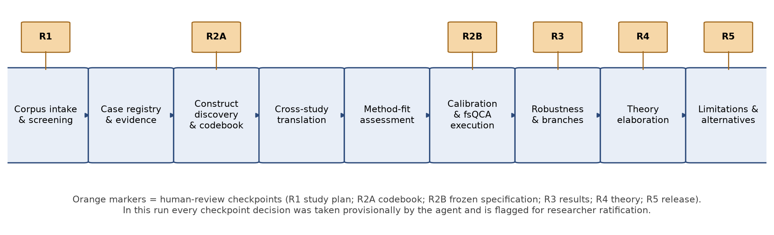
Figure 1. Workflow and human-review checkpoints.
Checkpoint | Decision taken provisionally by the agent | What a researcher must ratify or revise
R1 Study plan | Outcome = expert authority retained/reconstructed (EAR); unit = expert group within a deployment setting; bounded-corpus stance (the 30 articles are not treated as an exhaustive review). | Outcome choice; unit of analysis; whether field-level studies (Faulconbridge; Li) may enter the case pool.
R2A Codebook | Five conditions (SUB, BRG, VAL, MGT, JUR) plus two auxiliary constructs (OPQ scope check; PERF exploratory). Four-point calibration anchors. | Construct definitions; the decision to treat opacity as scope rather than condition; merging of Strich with Mayer banking; splitting of Pieper and van den Broek actor groups.
R2B Frozen specification | Consistency 0.80, PRI 0.60, frequency 1; directional expectations SUB absent, BRG present, VAL present, MGT absent, JUR present; complete-case baseline with Li in sensitivity only. | Threshold choices; directional expectations; missingness policy.
R3 Results | Solutions computed for EAR and ~EAR; contradictory row and deviant cases listed; simple-rival comparison run. | Whether the contradictory row invalidates the ~EAR term; acceptability of PRI 0.71 for that row.
R4 Theory | Five propositions with mechanisms, supporting and deviant cases, rivals and boundaries (Section 11). | Whether relational reconstruction and technical fragility deserve coded conditions in a second pass.
R5 Release | Document released as provisional record; no claims marked verified. | Independent coding of at least the four displacement cases and the five contradictory-row cases before any external use.

4. Corpus intake and screening
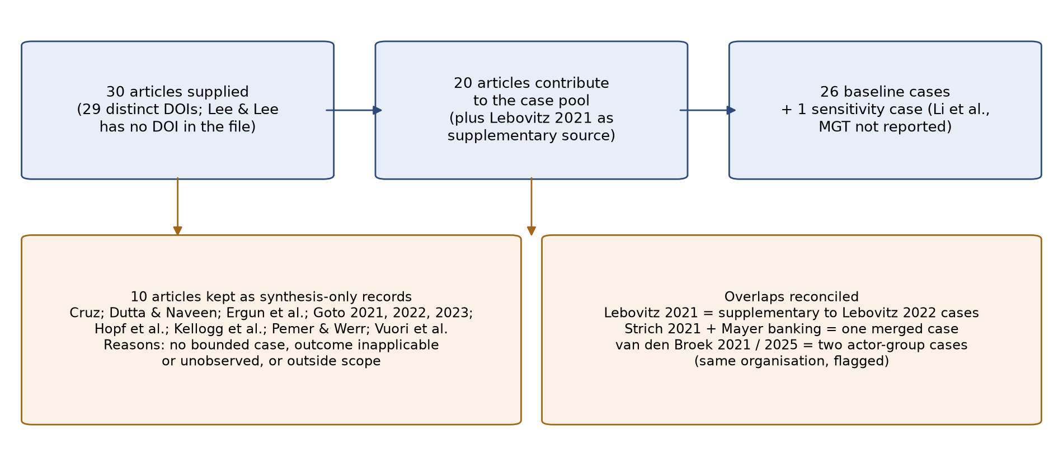
Figure 2. From supplied articles to analytical cases.
Each article was classified by evidence type and by whether it supports a bounded case for which the outcome construct is observable. Synthesis-only records inform construct development, rival explanations and boundary conditions but contribute no memberships.
ID | Article | Evidence type | Decision | Reason
A01 | Asatiani et al. 2021 (JAIS) | empirical qualitative case | include | Bounded setting: Danish Business Authority ML Lab and case workers
A02 | Cruz 2024 (I&O) | empirical interview study (42 recruiters, many organisations) | synthesis only | No bounded case; cross-organisational perceptions; used as corroborating field evidence
A03 | Dutta & Naveen 2025 (HRM) | empirical interview study (43 HR leaders, many organisations) | synthesis only | No bounded case; aggregate account of recruitment practice change
A04 | Einola & Khoreva 2023 (HRM) | empirical qualitative case | include | One company (Wizz), two separable solution/actor groups
A05 | Ergun et al. 2026 (JIT) | empirical qualitative case | synthesis only | Outcome construct inapplicable: leadership focus; no consequential AI-mediated judgments observed
A06 | Faulconbridge et al. 2024 (Organization Studies) | empirical interview study across PSFs | include (field-level, flagged) | Two professional fields (accounting, law); lower evidence resolution
A07 | Giannitsas et al. 2026 (I&O) | empirical nested case | include | Three departmental implementations in one airline
A08 | Goto 2021 (JPO) | empirical, profession level (texts + interviews) | synthesis only | Collective identity at profession level; no deployment setting
A09 | Goto 2022 (JPO) | empirical qualitative case (pre-deployment) | synthesis only | Prospective sensemaking 2017-19; outcome not observable
A10 | Goto 2023 (Research Policy) | empirical qualitative, field level (Big Four Japan) | synthesis only | Service R&D process; auditors' discretion over AI judgments not the focus
A11 | Grange et al. 2025 (ISJ) | collaborative practice research, three projects | include (pooled, flagged) | Three GenAI design sprints reported mainly cross-project; pooled as one case
A12 | Gronsund & Aanestad 2020 (JSIS) | empirical longitudinal case | include | Maritime trade analytics organisation, two years
A13 | Hopf et al. 2025 (JIT) | empirical qualitative case | synthesis only | Scope: conversational agents for health behaviour; not expert judgment in knowledge work
A14 | Kellogg et al. 2025 (I&O) | empirical interviews after field experiment (BCG) | synthesis only | Outcome not observed in situ; juniors' anticipated coaching of seniors
A15 | Lebovitz et al. 2021 (MISQ) | empirical field study | supplementary source | Same hospital/tools as Lebovitz et al. 2022; used as supplementary evidence, not a separate case (pseudoreplication risk)
A16 | Lebovitz et al. 2022 (Org Science) | empirical field study | include | Three radiology departments (lung, breast, bone age)
A17 | Lee & Lee 2024 (MISQ curated case) | short case study | include (flagged: short report) | Korean SSIS blind-spot ML coexisting with local-government heuristics
A18 | Li et al. 2025 (DSS) | mixed methods (10 interviews + survey) | sensitivity only | Field-level physicians; MGT not reported (unknown), so excluded from complete-case baseline
A19 | Mayer et al. 2025 (JMS) | comparative field study (3 settings) | include | Banking merged with Strich et al. 2021 (probable same loan-consulting site: shared author, identical setting description; not confirmed in text); biotechnology separate; recruitment flagged for probable overlap with the van den Broek organisation (shared author)
A20 | Mirkovski et al. 2025 (ISJ) | design/action case | include (flagged: design-led) | Australian e-retailer HAIAPI framework
A21 | Monod et al. 2024 (I&O) | empirical qualitative case | include (flagged: manager-only informants) | Chinese service firm Alpha, AI sales assistant in customer service
A22 | Pemer & Werr 2025 (JMS) | empirical interview study (Big Four Sweden) | synthesis only | Digitalisation broadly; AI-mediated judgments not the focus
A23 | Pieper & Gleasure 2025 (ISJ) | empirical qualitative case | include | Radiology AI; specialists and non-specialists separable actor groups
A24 | Strich et al. 2021 (JAIS) | empirical qualitative case | include (merged) | Loan consulting with substitutive AI; merged with Mayer banking
A25 | van den Broek et al. 2021 (MISQ) | ethnography | include | Hiring ML development; HR experts and developers
A26 | van den Broek et al. 2025 (JMS, fairness) | ethnography | include (overlap flagged) | Same organisation; distinct actor group (line/hiring managers)
A27 | van Giffen et al. 2025 (ISJ) | practitioner research, 5 years | include | Siemens lean quality management
A28 | Van Krimpen & Van der Voort 2025 (I&O) | empirical qualitative case | include | Dutch inspectorate ML co-creation
A29 | Vuori et al. 2025 (JMS) | empirical longitudinal case | synthesis only | AI profiles workers' expertise; workers are objects, not authors, of the AI-mediated judgment
A30 | Waardenburg et al. 2022 (Org Science) | ethnography (31 months) | include | Dutch police predictive policing brokers

5. Case registry
Case = an identifiable expert group facing a specific AI system in a bounded setting over an observed period. Field-level cases (multi-firm interview studies) are flagged and removed in the bounded-only robustness check. Flags record evidence limitations that a reviewer should weigh.
Case | Source | Setting | AI system | Expert group | Resolution | Flags
ASA | A01 | Danish Business Authority (public agency) | In-house ML models (fraud/risk flags) built by ML Lab | Case workers | bounded | JUR: statutory mandate but not a licensed profession
EIN-D | A04 | Wizz (Finnish media company), digital media group | Campaign optimisation / ML advertising tools | Digital media planners and specialists | bounded | EAR: discretion retained but job content narrowed ("I just pilot")
EIN-T | A04 | Wizz, traditional media group | Rule-based/robotic automation of advertisement slot booking | TV and print planners/operators | bounded | EAR: discretion preserved mainly because the robot failed and needed supervision
FAU-A | A06 | UK accounting firms (multiple firms) | Supervised ML for data extraction/analysis (e.g., audit/tax analytics) | Accountants (partners and staff) | field | res: multi-firm interview evidence
FAU-L | A06 | UK law firms (multiple firms) | ML document review (e.g., Relativity) for due diligence, discovery | Lawyers | field | res: multi-firm interview evidence
GIA-CRM | A07 | AlphaAir CRM department | In-house clustering/segmentation models | CRM analysts (model builders and users) serving marketing | bounded | BRG: bridging is analyst-to-marketing rather than developer-to-expert
GIA-RM | A07 | AlphaAir Revenue Management | Third-party ML revenue optimisation platform | Revenue management analysts | bounded
GIA-DSL | A07 | AlphaAir Data Science Lab / cargo department | In-house cargo-space forecasting and allocation model | Cargo managers (domain) with DSL data scientists (developers) | bounded
GRA | A11 | Three organisations' GenAI-enabled design sprints (pooled) | GenAI (LLM) for problem framing and idea generation | Innovation team members and facilitator | pooled | res: three projects pooled; per-project variation thinly reported
GRO | A12 | International maritime trade analytics firm | Algorithmic vessel/trade data analysis and prediction | Trade analysts | bounded | MGT: strategic scaling intent inferred from "detecting human bottleneck" section
LEB-LUNG | A16 | US hospital, lung cancer screening department | Vendor ML diagnostic tool | Diagnostic radiologists | bounded | cluster: same hospital as LEB-BREAST, LEB-BONE
LEB-BREAST | A16 | US hospital, breast imaging department | Vendor ML diagnostic tool | Diagnostic radiologists | bounded | cluster: same hospital
LEB-BONE | A16 | US hospital, paediatric bone age department | Vendor ML bone-age tool | Diagnostic radiologists | bounded | cluster: same hospital
LEE | A17 | Korean Social Security Information Service and local governments | ML blind-spot identification model (plus rule-based model) | Local government welfare officials | bounded (short) | res: short teaching-case format; limited depth
LI | A18 | Chinese hospitals (multiple) | AI-aided diagnostic systems | Physicians | field | MGT: not reported in available text; unknown
MAY-BIO | A19 | Biotechnology firm seed sorting | AI tool automating selection of high-quality seeds | Seed sorters (clients: supply chain managers) | bounded | EAR: contested: authority reconstructed relationally (enhancing explanations) although decisions cannot be overruled
MAY-REC | A19 | Large organisation recruitment function | AI personality-based candidate selection | Recruiters (clients: hiring managers) | bounded | EAR: contested as above; recruiters shaped AI reports but not decisions; overlap: probable same organisation as VDB-HR/VDB-LM (shared author E. van den Broek; similar AI); unverified
STR-BANK | A24,A19 | Loan consulting company / bank (CleverLoan) | Substitutive loan decision AI | Loan consultants | bounded | overlap: two articles, probable same site (merged; inferred from shared author and identical description)
MIR | A20 | Australian e-retailer (small business) | GPT-based HAIAPI framework for product innovation | Owner-managers / product team | bounded (design-led) | res: outcome partly built in by framework design
MON | A21 | Alpha (large Chinese service firm) customer-service unit | NLP AI sales assistant (chatbot + insights) | CS salespeople (outsourced) | bounded (manager-only informants) | informants: salespeople not interviewed
PIE-S | A23 | German medical care centre radiology (specialists) | AI-Rad Companion (Siemens Healthineers) | Radiology specialists | bounded
PIE-N | A23 | Same centre, non-specialist physicians | AI-Rad Companion | Non-specialist physicians | bounded | JUR: licensed physicians but outside radiology jurisdiction
VKR | A28 | Dutch inspectorate | ML risk scores for fraudulent companies from online adverts | Inspectors | bounded | EAR: part of end-user community engaged; new boundary with remaining inspectors
WAA | A30 | Dutch police (national predictive policing) | Learning algorithm predicting crime incidents | Intelligence officers (brokers) and police management | bounded | EAR: authority relocated within domain to brokers; management dependent on brokers
VGI | A27 | Siemens Digital Industries lean quality management | Predictive quality/test-reduction AI | Quality engineers and workers | bounded
VDB-HR | A25 | Large international organisation HR / hiring ML development | ML candidate assessment system | HR professionals / recruiters with developers | bounded | overlap: same organisation as VDB-LM
VDB-LM | A26 | Same organisation, line/hiring managers | Same ML hiring tool | Line (hiring) managers | bounded | overlap: same organisation as VDB-HR; different actor group

6. Construct discovery and codebook
Constructs were developed by reading abstracts, findings and discussion sections of all 30 articles and recording relational statements (who did what to whom, with what consequence for whose judgment). Five relational themes recurred across at least eight articles and were separable from the outcome: how the AI was positioned relative to the expert judgment; whether anyone bridged the developer-expert boundary; whether experts tested the AI against their own knowledge; whose logic governed the deployment; and how institutionalised the experts' claim to the judgment domain was. Two further themes, opacity and visible performance shortfall, were recorded but handled separately (Section 10).
Code | Construct | Full membership (1) | More in than out (0.67) | More out than in (0.33) | Full non-membership (0) | Must not count as evidence
EAR | Expert authority over AI-mediated judgment retained or reconstructed | Experts hold and exercise legitimate discretion to shape or overrule consequential AI-mediated judgments; recognised by management, clients or developers. | Discretion exercised but contested, informal, or relocated within the expert domain (e.g., brokers); or relational authority rebuilt without formal override. | Formal discretion exists but is hollowed (dependency, inability to understand or affect outputs) or exercised only covertly. | Experts cannot interact with or overrule outputs; authority relocated to system, managers or another group. | Frequency of use; satisfaction; identity talk; AI accuracy.
SUB | Substitutive positioning of the AI (judgment assigned to AI; experts cannot formally interact/overrule) | AI executes the judgment; no formal interaction or override. | AI executes by default; override possible only by exception/escalation. | AI flags or recommends; experts decide but default is to follow. | Advisory or exploratory only. | Managers' automation rhetoric without implemented design.
BRG | Boundary-bridging infrastructure between AI developers and domain experts (brokers, co-development, mutual learning) | Dedicated roles or routines connecting developers and experts throughout (brokers, co-development, mutual learning). | Substantial but partial or late bridging; bridging to one expert group only. | Ad hoc contact; training sessions only. | No contact; vendor tool; experts uninvolved in development. | Job titles alone; generic training.
VAL | Expert-led validation practices (experts test AI outputs against their own know-how/ground truth in situ) | Systematic in-situ testing of outputs against expert knowledge or ground truth, sustained over time. | Regular but informal checking. | Initial testing then abandoned; sporadic comparison. | No testing possible or none observed. | Developers' accuracy metrics; the experts' trust statements.
MGT | Managerial efficiency/control logic dominant in deployment (vs. expert- or quality-initiated) | Deployment initiated and governed by management for efficiency, cost or control; top-down mandate. | Management-driven with efficiency aims but with expert or quality co-aims. | Expert- or quality-initiated with efficiency as a secondary justification. | Expert-, researcher- or innovation-initiated; no control aim. | Sector-level regulation; generic strategic statements.
JUR | Institutionalised professional jurisdiction of the expert group over the judgment domain | Licensed or legally accountable profession with exclusive claim over the judgment (physicians, lawyers, auditors). | Public-authority or statutory mandate without licensure (inspectors, case workers). | Occupational expertise without institutional closure (analysts, recruiters, consultants, planners). | Low-discretion service roles (outsourced sales). | Organisational seniority; informal respect.
OPQ | Experienced opacity of AI outputs (scope check) | Experts report inability to understand how outputs are produced. | Partial understanding; opacity noted but manageable. | Mostly interpretable. | Rule-based or fully interpretable. | Model type alone.
PERF | Visible AI performance shortfall relative to task demands (exploratory) | Repeated, consequential errors visible to experts. | Noticeable errors or irrelevance in part of the task. | Occasional disagreement. | Performance accepted as adequate. | Experts' distrust statements without observed errors.

Conceptual and field-level records (synthesis-only). Cruz (2024) supports MGT and VAL as organisational levers (oversight, prioritisation, trust configurations). Dutta and Naveen (2025) describe recruiters' judgment being reshaped by generative AI in an emerging-market HR field, corroborating low-JUR vulnerability. Kellogg et al. (2025) document failed junior-to-senior bridging and are the strongest warning that bridging roles can be present in name yet fail in practice. Vuori et al. (2025) show covert data manipulation as a response to AI profiling, a mechanism also attempted by loan consultants (Strich et al. 2021). Goto (2021, 2022, 2023) and Pemer and Werr (2025) describe profession-level anticipatory work in auditing and consulting that precedes deployment; they inform the JUR boundary condition. Hopf et al. (2025) and Ergun et al. (2026) are outside the outcome construct's scope.

7. Cross-study translation and method-fit assessment
Cross-study translation asked whether the same words denote the same relations. Two translation decisions mattered most. First, "brokerage" in Waardenburg et al. (2022) and "mutual learning" in van den Broek et al. (2021) were both coded as bridging infrastructure although their consequences differ: brokers substituted their own judgment for the algorithm, whereas mutual learning reshaped the algorithm. The codebook therefore defines BRG by structure (a sustained connection across the developer-expert boundary), not by its effect. Second, "authority" in Mayer et al. (2025) is relational (recognition by clients), whereas in Strich et al. (2021) and van den Broek et al. (2025) it is decision control. The outcome definition admits both at the 0.67 level but this is a contested interpretive choice carried as Branch B. Authorship overlap also matters for case independence: Mayer et al. (2025) share an author with Strich et al. (2021) (banking) and with the van den Broek ethnographies (recruitment); the banking case was merged with Strich on the basis of an identical setting description, and the recruitment case is flagged as a probable overlap with the van den Broek organisation and removed jointly with it in a robustness check (Section 10).
Candidate route | Evidence in this corpus | Assessment
Configurational comparison (fsQCA) | 26 cases with variation on all five conditions; end states reported in most studies; 13 of 32 configurations observed. | Defensible for an end-state comparison; limited diversity (19 remainders) and outcome skew (4 negative cases) constrain inference. Selected as the executed route.
Comparative process analysis | At least 10 contributing studies are longitudinal or ethnographic with explicit phases (van den Broek 2021; Waardenburg; Gronsund & Aanestad; Pieper & Gleasure; Giannitsas; van Giffen; Monod; Lebovitz 2022; Mayer; Asatiani). | Strong fit: the conditions (bridging, validation) and the outcome co-evolve; sequence matters (Alpha: empowerment then control; AlphaAir cargo: automation then intervention). Recommended as the complementary route; not executable from published end-state summaries alone.
Agent-based modelling | Interaction rules between experts, developers, managers and clients are described narratively but not parameterised. | Not warranted now; a specification-gap report would be the honest output.
Qualitative synthesis only | All 30 articles. | Always available; chosen for the 10 synthesis-only records and for interpreting deviant cases.

8. Calibration, coding matrix and missingness policy
Memberships use a four-point fuzzy scale (0, 0.33, 0.67, 1) anchored in the codebook. Exact 0.5 is not permitted. Unknown values are kept as unknown (Li et al. 2025, MGT) and never converted to 0, 0.5 or an imputed value. The baseline uses complete cases (26); the sensitivity analysis includes Li et al. under both plausible MGT values. Cells with contested readings carry an alternative value and define interpretive branches (Section 10).
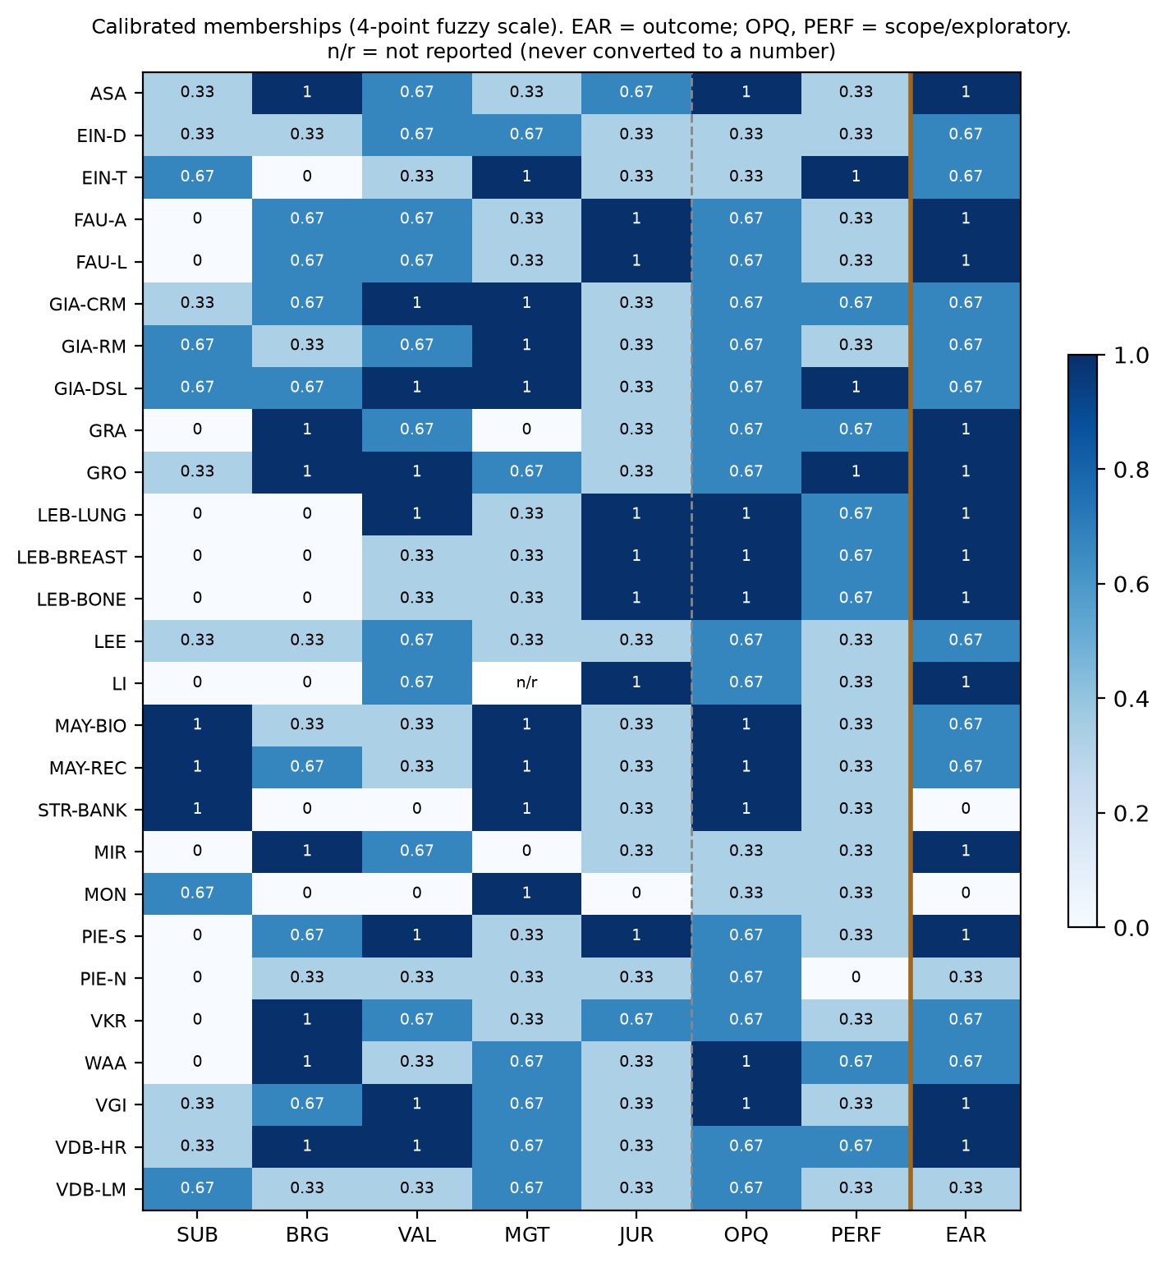
Figure 3. Calibrated memberships for all cases (n/r = not reported).
Case | EAR | SUB | BRG | VAL | MGT | JUR | OPQ | PERF
ASA | 1 | 0.33 | 1 | 0.67 | 0.33 | 0.67 | 1 | 0.33
EIN-D | 0.67 | 0.33 | 0.33 | 0.67 | 0.67 | 0.33 | 0.33 | 0.33
EIN-T | 0.67 | 0.67 | 0 | 0.33 | 1 | 0.33 | 0.33 | 1
FAU-A | 1 | 0 | 0.67 | 0.67 | 0.33 | 1 | 0.67 | 0.33
FAU-L | 1 | 0 | 0.67 | 0.67 | 0.33 | 1 | 0.67 | 0.33
GIA-CRM | 0.67 | 0.33 | 0.67 | 1 | 1 | 0.33 | 0.67 | 0.67
GIA-RM | 0.67 | 0.67 | 0.33 | 0.67 | 1 | 0.33 | 0.67 | 0.33
GIA-DSL | 0.67 | 0.67 | 0.67 | 1 | 1 | 0.33 | 0.67 | 1
GRA | 1 | 0 | 1 | 0.67 | 0 | 0.33 | 0.67 | 0.67
GRO | 1 | 0.33 | 1 | 1 | 0.67 | 0.33 | 0.67 | 1
LEB-LUNG | 1 | 0 | 0 | 1 | 0.33 | 1 | 1 | 0.67
LEB-BREAST | 1 | 0 | 0 | 0.33 | 0.33 | 1 | 1 | 0.67
LEB-BONE | 1 | 0 | 0 | 0.33 | 0.33 | 1 | 1 | 0.67
LEE | 0.67 | 0.33 | 0.33 | 0.67 | 0.33 | 0.33 | 0.67 | 0.33
LI | 1 | 0 | 0 | 0.67 | n/r | 1 | 0.67 | 0.33
MAY-BIO | 0.67 (alt 0.33) | 1 | 0.33 | 0.33 | 1 | 0.33 | 1 | 0.33
MAY-REC | 0.67 (alt 0.33) | 1 | 0.67 | 0.33 | 1 | 0.33 | 1 | 0.33
STR-BANK | 0 | 1 | 0 | 0 | 1 | 0.33 | 1 | 0.33
MIR | 1 | 0 | 1 | 0.67 | 0 | 0.33 | 0.33 | 0.33
MON | 0 | 0.67 | 0 | 0 | 1 | 0 | 0.33 | 0.33
PIE-S | 1 | 0 | 0.67 | 1 | 0.33 | 1 | 0.67 | 0.33
PIE-N | 0.33 | 0 | 0.33 | 0.33 | 0.33 | 0.33 | 0.67 | 0
VKR | 0.67 | 0 | 1 | 0.67 | 0.33 | 0.67 | 0.67 | 0.33
WAA | 0.67 (alt 1) | 0 | 1 | 0.33 | 0.67 | 0.33 | 1 | 0.67
VGI | 1 | 0.33 | 0.67 | 1 | 0.67 | 0.33 | 1 | 0.33
VDB-HR | 1 | 0.33 | 1 | 1 | 0.67 | 0.33 | 0.67 | 0.67
VDB-LM | 0.33 | 0.67 | 0.33 | 0.33 | 0.67 | 0.33 | 0.67 | 0.33

Outcome distribution: 22 cases with EAR greater than 0.5, four with EAR less than 0.5. OPQ exceeds 0.5 in 22 of 26 cases and was therefore treated as a scope condition of the corpus (most studied AI was experienced as opaque) rather than as a causal condition; its inclusion is tested in Section 10.

9. Results

9.1 Necessity
Necessity consistency is reported for each condition and its negation against EAR and ~EAR, with coverage and relevance of necessity (RoN). The conventional 0.90 threshold is applied.
Condition | Consistency (EAR) | Coverage | RoN |  | Condition | Consistency (~EAR) | Coverage | RoN
SUB | 0.31 | 0.69 | 0.87 |  | SUB | 0.75 | 0.58 | 0.82
~SUB | 0.81 | 0.90 | 0.84 |  | ~SUB | 0.60 | 0.23 | 0.39
BRG | 0.67 | 0.95 | 0.95 |  | BRG | 0.55 | 0.27 | 0.55
~BRG | 0.48 | 0.76 | 0.82 |  | ~BRG | 0.90 | 0.48 | 0.68
VAL | 0.78 | 0.96 | 0.94 |  | VAL | 0.60 | 0.25 | 0.47
~VAL | 0.40 | 0.74 | 0.85 |  | ~VAL | 0.90 | 0.58 | 0.78
MGT | 0.57 | 0.72 | 0.71 |  | MGT | 0.95 | 0.41 | 0.54
~MGT | 0.53 | 0.97 | 0.98 |  | ~MGT | 0.35 | 0.22 | 0.65
JUR | 0.65 | 0.97 | 0.98 |  | JUR | 0.65 | 0.33 | 0.60
~JUR | 0.55 | 0.82 | 0.85 |  | ~JUR | 0.95 | 0.48 | 0.66

No condition is necessary for retention. For displacement, four negated or present conditions exceed 0.90 (MGT 0.95, ~JUR 0.95, ~BRG 0.90, ~VAL 0.90), but the outcome set has only four members and coverage is low (0.41-0.58), so these are candidate necessary conditions at best. MGT present in displacement has RoN 0.54, indicating a trivial necessary condition (managerial logic is widespread among retention cases too).

9.2 Truth table (observed rows)
SUB BRG VAL MGT JUR | n | Consistency (EAR) | PRI | EAR row | Cases
01101 | 5 | 1.00 | 1.00 | 1 | ASA, FAU-A, FAU-L, PIE-S, VKR
10010 | 5 | 0.64 | 0.29 | 0 | EIN-T, MAY-BIO, STR-BANK, MON, VDB-LM
01110 | 4 | 1.00 | 1.00 | 1 | GIA-CRM, GRO, VGI, VDB-HR
00001 | 2 | 1.00 | 1.00 | 1 | LEB-BREAST, LEB-BONE
01100 | 2 | 1.00 | 1.00 | 1 | GRA, MIR
00000 | 1 | 0.80 | 0.00 | 0 | PIE-N
00100 | 1 | 1.00 | 1.00 | 1 | LEE
00101 | 1 | 1.00 | 1.00 | 1 | LEB-LUNG
00110 | 1 | 1.00 | 1.00 | 1 | EIN-D
01010 | 1 | 1.00 | 1.00 | 1 | WAA
10110 | 1 | 1.00 | 1.00 | 1 | GIA-RM
11010 | 1 | 1.00 | 1.00 | 1 | MAY-REC
11110 | 1 | 1.00 | 1.00 | 1 | GIA-DSL

13 of 32 configurations are observed; 19 are logical remainders. Row 10010 (SUB*~BRG*~VAL*MGT*~JUR) is contradictory: five cases, consistency 0.64 for EAR and 0.85 for ~EAR, with two members (EIN-T, MAY-BIO) retaining partial authority and three (STR-BANK, MON, VDB-LM) losing it. It is coded 0 for EAR and 1 for ~EAR under the frozen thresholds, but the within-row disagreement is the most informative pattern in the data (Section 11).

9.3 Sufficiency for retention of expert authority (EAR)
Conservative (complex) solution, no remainders used.
Term | Consistency | PRI | Raw coverage | Unique coverage | Typical cases (member >0.5, EAR >0.5) | Deviant (member >0.5, EAR <=0.5)
~SUB*~BRG*~MGT*JUR | 1.00 | 1.00 | 0.24 | 0.04 | LEB-LUNG, LEB-BREAST, LEB-BONE
~SUB*VAL*~MGT | 1.00 | 1.00 | 0.46 | 0.17 | ASA, FAU-A, FAU-L, GRA, LEB-LUNG, LEE, MIR, PIE-S, VKR
BRG*MGT*~JUR | 1.00 | 1.00 | 0.38 | 0.04 | GIA-CRM, GIA-DSL, GRO, MAY-REC, WAA, VGI, VDB-HR
VAL*MGT*~JUR | 1.00 | 1.00 | 0.40 | 0.05 | EIN-D, GIA-CRM, GIA-RM, GIA-DSL, GRO, VGI, VDB-HR
Solution | 1.00 | 1.00 | 0.76

Parsimonious solution, all remainders available.
Term | Consistency | PRI | Raw coverage | Unique coverage | Typical cases (member >0.5, EAR >0.5) | Deviant (member >0.5, EAR <=0.5)
BRG | 0.95 | 0.93 | 0.67 | 0.09 | ASA, FAU-A, FAU-L, GIA-CRM, GIA-DSL, GRA, GRO, MAY-REC, MIR, PIE-S, VKR, WAA, VGI, VDB-HR
VAL | 0.96 | 0.94 | 0.78 | 0.07 | ASA, EIN-D, FAU-A, FAU-L, GIA-CRM, GIA-RM, GIA-DSL, GRA, GRO, LEB-LUNG, LEE, MIR, PIE-S, VKR, VGI, VDB-HR
JUR | 0.97 | 0.96 | 0.65 | 0.10 | ASA, FAU-A, FAU-L, LEB-LUNG, LEB-BREAST, LEB-BONE, PIE-S, VKR
Solution | 0.92 | 0.90 | 0.96

Intermediate solution; directional expectations SUB absent, BRG present, VAL present, MGT absent, JUR present.
Term | Consistency | PRI | Raw coverage | Unique coverage | Typical cases (member >0.5, EAR >0.5) | Deviant (member >0.5, EAR <=0.5)
~SUB*~MGT*JUR | 1.00 | 1.00 | 0.45 | 0.04 | ASA, FAU-A, FAU-L, LEB-LUNG, LEB-BREAST, LEB-BONE, PIE-S, VKR
BRG | 0.95 | 0.93 | 0.67 | 0.09 | ASA, FAU-A, FAU-L, GIA-CRM, GIA-DSL, GRA, GRO, MAY-REC, MIR, PIE-S, VKR, WAA, VGI, VDB-HR
VAL | 0.96 | 0.94 | 0.78 | 0.12 | ASA, EIN-D, FAU-A, FAU-L, GIA-CRM, GIA-RM, GIA-DSL, GRA, GRO, LEB-LUNG, LEE, MIR, PIE-S, VKR, VGI, VDB-HR
Solution | 0.93 | 0.91 | 0.90

Reading. The three intermediate paths are: (i) a jurisdiction path, ~SUB*~MGT*JUR, in which licensed professionals facing advisory AI under non-managerial deployment keep authority even without bridging or validation (uniquely: the two unengaged radiology departments); (ii) a bridging path, BRG; (iii) a validation path, VAL. Paths (ii) and (iii) overlap heavily (ten cases are members of both), and the parsimonious disjunction BRG + VAL + JUR is the more economical statement. The intermediate solution adds only 0.035 unique coverage over BRG + VAL through the jurisdiction term, and that increment rests on two clustered cases from one hospital.
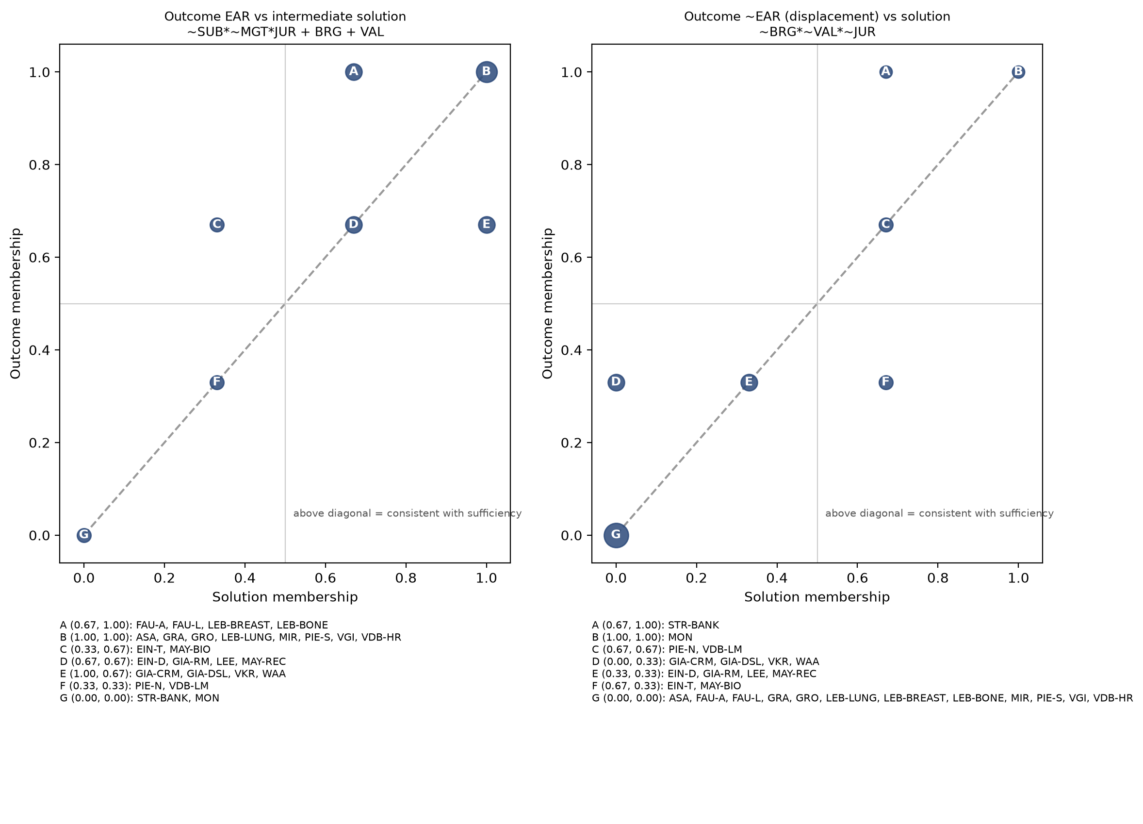
Figure 4. Solution membership against outcome membership; letters index case clusters listed beneath each panel.

9.4 Sufficiency for displacement (~EAR)
Conservative solution.
Term | Consistency | PRI | Raw coverage | Unique coverage | Typical cases | Deviant cases
~SUB*~BRG*~VAL*~MGT*~JUR | 1.00 | 1.00 | 0.25 | 0.10 | PIE-N
SUB*~BRG*~VAL*MGT*~JUR | 0.85 | 0.71 | 0.60 | 0.45 | STR-BANK, MON, VDB-LM | EIN-T, MAY-BIO
Solution | 0.87 | 0.75 | 0.70

Intermediate and parsimonious solutions (identical).
Term | Consistency | PRI | Raw coverage | Unique coverage | Typical cases | Deviant cases
~BRG*~VAL*~JUR | 0.88 | 0.78 | 0.75 | 0.75 | STR-BANK, MON, PIE-N, VDB-LM | EIN-T, MAY-BIO
Solution | 0.88 | 0.78 | 0.75

Reading. Displacement occurred where none of the three buffers was present. The conservative solution distinguishes imposed displacement (substitutive AI under managerial logic for low-jurisdiction workers: loan consultants, Alpha salespeople, hiring line managers) from dependency drift (non-specialist physicians who could override an advisory tool but progressively stopped exercising independent judgment). The second route is a single case and the first contains two deviant members; the ~EAR solution is therefore reported as suggestive.

9.5 Simple-rival comparison
Following the Project's practice of testing complex solutions against simpler rivals, single conditions and simpler disjunctions were compared with the minimised solutions.
Model for EAR | Consistency | PRI | Coverage
VAL alone | 0.96 | 0.94 | 0.78
BRG alone | 0.95 | 0.93 | 0.67
JUR alone | 0.97 | 0.96 | 0.65
~SUB alone | 0.90 | 0.88 | 0.81
~MGT alone | 0.97 | 0.96 | 0.53
BRG + VAL | 0.93 | 0.91 | 0.86
BRG + VAL + JUR (parsimonious) | 0.92 | 0.90 | 0.96
~SUB*~MGT*JUR + BRG + VAL (intermediate) | 0.93 | 0.91 | 0.90
~SUB + ~MGT (design/logic only) | 0.90 | 0.88 | 0.81
~SUB*~MGT | 0.97 | 0.96 | 0.53

VAL alone (consistency 0.96, coverage 0.78) and JUR alone (0.98, 0.65) are strong single-condition accounts. The configurational solutions gain coverage (0.90-0.97) at a modest cost in consistency. What the configurational reading adds beyond "any buffer suffices" is the identification of the cases where buffers were absent and authority nevertheless survived (EIN-T, MAY-BIO), which single conditions cannot locate. Design and logic alone (~SUB + ~MGT) reach coverage 0.81 with consistency 0.90: they are informative but inferior to the buffer account.

10. Robustness, scope checks and interpretive branches
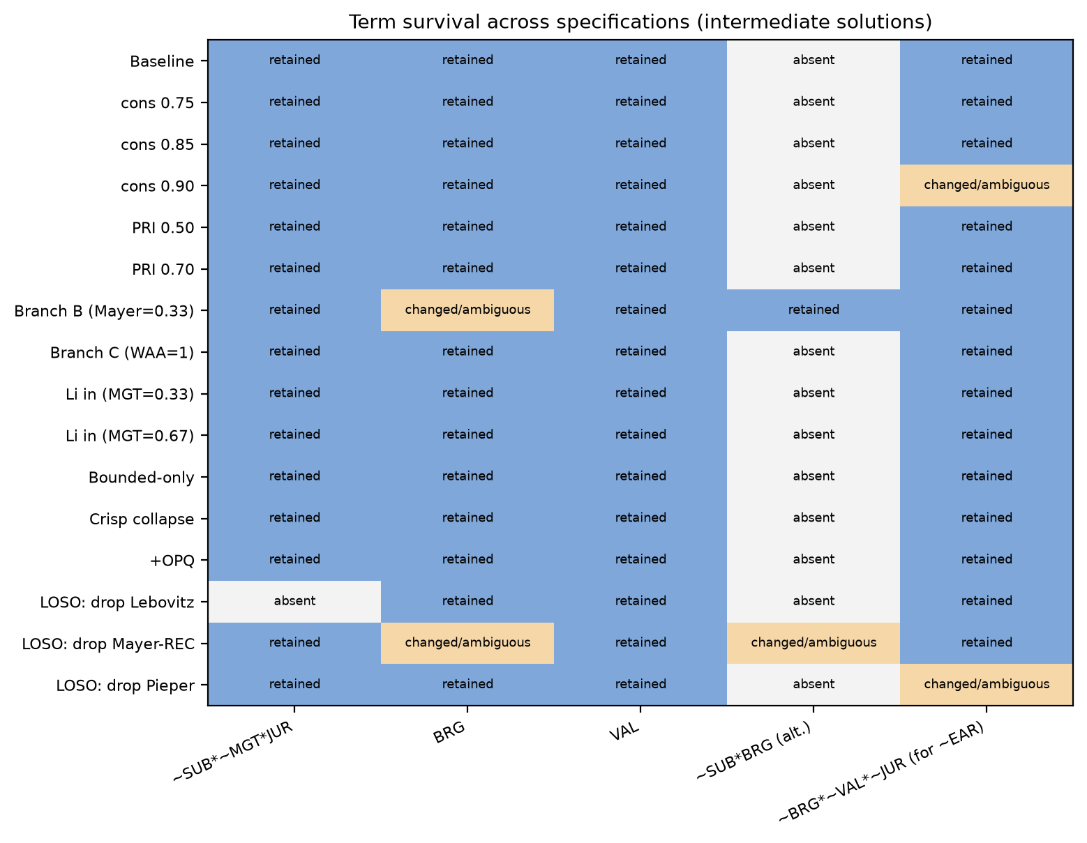
Figure 5. Survival of solution terms across specifications.
Specification | EAR intermediate solution | ~EAR solution | Comment
Baseline (cons 0.80, PRI 0.60, n=26) | ~SUB*~MGT*JUR + BRG + VAL | ~BRG*~VAL*~JUR | Reference.
Consistency 0.75 / 0.85 | unchanged | unchanged | Row inclusion insensitive within this range.
Consistency 0.90 | unchanged | PIE-N row only; solution becomes ~SUB*~BRG*~VAL*~MGT*~JUR | Contradictory row 10010 (cons 0.85) drops out; imposed-displacement path lost.
PRI 0.50 / 0.70 | unchanged | unchanged | Row 10010 PRI 0.71 remains binding near 0.70.
Branch B: Mayer cases read as decision control (EAR 0.33) | Two models: ~SUB*~MGT*JUR + ~SUB*BRG + VAL, or with ~SUB*BRG*MGT | ~BRG*~VAL*~JUR (consistency rises to 0.94) | Bridging path becomes conditional on non-substitutive design; displacement term strengthens. The interpretive choice about relational authority changes the retention theory.
Branch C: Waardenburg brokers as full retention (EAR 1) | unchanged | n/a | No effect.
Li et al. included (MGT 0.33 or 0.67) | unchanged | unchanged | Unknown handled by bounds, not imputation.
Bounded cases only (drop FAU-A, FAU-L, GRA, LEE, MIR) | unchanged (coverage 0.87) | unchanged | Field-level and design-led cases do not drive the result.
Crisp collapse (>0.5 to 1) | unchanged | unchanged | Four-point calibration is not doing the work.
OPQ added as sixth condition | unchanged (parsimonious and intermediate) | not run | Opacity near-constant (22/26); scope condition.
Exploratory PERF model (replaces MGT; n=27) | ~SUB*JUR + BRG + VAL | SUB*~BRG*~VAL*~JUR (deviants EIN-T, MAY-BIO persist) | Performance shortfall does not rescue the contradictory row at the set level; EIN-T remains uncovered. The mechanism is visible qualitatively, not configurationally.
Drop probable-overlap trio (MAY-REC, VDB-HR, VDB-LM; n=23) | Two models: ~SUB*~MGT*JUR + ~SUB*BRG + VAL, or with ~SUB*BRG*MGT | ~BRG*~VAL*~JUR (consistency 0.85, coverage 0.71) | As in Branch B, the stand-alone bridging path depends on the contested MAY-REC case; without it bridging retains authority only where the design is non-substitutive.
Leave-one-study-out (19 studies) | Stable for 16 studies. Drop Lebovitz 2022: BRG + VAL (JUR path disappears). Drop Giannitsas: VAL narrows to ~SUB*VAL. Drop Mayer recruitment: two models. | Stable for 16 studies. Drop Strich/Mayer banking or Monod: two models. Drop Pieper: SUB*~BRG*~VAL*MGT*~JUR. | The jurisdiction path is a one-study result; the displacement term depends on each of its three imposed-displacement cases.

Robustness verdict
Survives: the buffer account of retention (BRG + VAL as the core, JUR as a one-study extension). Needs qualification: the jurisdiction path (single hospital, two unengaged departments), the displacement term (contradictory row, four cases), and the bridging path under Branch B. Should not be claimed: that substitutive design or managerial logic is sufficient for displacement; that opacity differentiates cases; that performance shortfall is a configurational condition.

11. Configurational theory elaboration
Three levels of inference are kept apart. Set-analytic findings state what the observed memberships support. Qualitative interpretations state what source passages support about processes. Theoretical propositions are broader claims that require further study. The register below links each proposition to its configuration, cases, mechanism, rival and boundary.
Existing theoretical claim being elaborated. The literature on algorithms at work often treats expert authority as threatened by substitutive, opaque AI deployed under managerial logics. This corpus shows that threat is widespread but displacement is rare, and that what separates displacement from retention is not the threat but the presence of buffers that keep expert knowledge in the loop.
# | Proposition | Configuration and fit | Supporting cases | Deviant or contrasting cases | Mechanism (from source evidence) | Rival explanation | Boundary / robustness
P1 | Expert authority is displaced only when all three buffers are absent: no bridging infrastructure, no expert-led validation and no institutionalised jurisdiction. | ~BRG*~VAL*~JUR -> ~EAR; cons 0.88, PRI 0.78, cov 0.75 | STR-BANK, MON, VDB-LM, PIE-N | EIN-T, MAY-BIO (same configuration, partial retention) | Without a channel to the developers, without a practice that makes expert knowledge consequential for outputs, and without an institutional claim, the organisation has no reason to re-admit expert judgment once the AI is in place. | Displacement is caused by substitutive design and managerial intent (SUB*MGT). Rejected as sufficient: SUB*MGT has consistency 0.58 for ~EAR because many retention cases share it. | Four negative cases; the term depends on a contradictory row. Status: suggestive.
P2 | Any one buffer is sufficient for retention; the buffers are substitutes, not complements. | BRG + VAL + JUR -> EAR; cons 0.92, cov 0.97 | 22 retention cases | None below 0.5; partial: EIN-T and MAY-BIO retained without any buffer | Bridging makes expert knowledge an input to the system (van den Broek 2021; Asatiani); validation makes it a check on outputs (Lebovitz lung; Gronsund); jurisdiction makes it a legal requirement regardless (Faulconbridge; Lebovitz breast/bone). | Buffers are consequences of retained authority rather than causes (reverse causation), especially for VAL. | Equifinality is well supported. The stand-alone BRG path depends on MAY-REC (contested, probable overlap); under Branch B or without that case, bridging suffices only with non-substitutive design (~SUB*BRG). The JUR path rests on one study.
P3 | Jurisdiction preserves authority without engagement: licensed professionals facing advisory AI under non-managerial deployment keep authority even when they neither bridge nor validate. | ~SUB*~MGT*JUR -> EAR; cons 1.00, unique cov 0.035 | LEB-BREAST, LEB-BONE (uniquely); also ASA, FAU-A, FAU-L, LEB-LUNG, PIE-S, VKR | PIE-N: physicians outside the radiology jurisdiction drifted into dependency | Legal accountability keeps the final signature with the professional (Faulconbridge p13, p16); no one can require deference to the tool. | The unengaged departments retained authority because the tools were poor, not because of jurisdiction (PERF 0.67 in those cases). | One hospital study; disappears in LOSO. Status: hypothesis for a new study.
P4 | Where buffers are absent, authority can still survive through two unplanned mechanisms: technical fragility that forces human intervention, and relational reconstruction towards clients. | Within row SUB*~BRG*~VAL*MGT*~JUR: EIN-T (PERF 1), MAY-BIO (client-facing enhancement) | EIN-T, MAY-BIO | STR-BANK, MON, VDB-LM (same row, displaced) | A robot that "bangs his head on the wall" needs planners' tacit knowledge (Einola & Khoreva p9, p12); sorters who learned clients' needs enriched AI outputs and were re-recognised as experts (Mayer et al. p24-26). | Measurement: MAY-BIO belongs at 0.33 under a decision-control reading (Branch B), leaving only technical fragility. | Two cases; qualitative not configurational. Status: lead for coding PERF and client-facing work as conditions in a second pass.
P5 | Displacement has two routes: imposed (substitutive AI under managerial logic for low-jurisdiction workers) and drift (advisory AI whose accuracy gradually substitutes for independent judgment among non-jurisdiction users). | Conservative ~EAR: SUB*~BRG*~VAL*MGT*~JUR + ~SUB*~BRG*~VAL*~MGT*~JUR | Imposed: STR-BANK, MON, VDB-LM. Drift: PIE-N | PIE-S (same tool, specialists retained authority) | Imposed: design removes the interaction surface (Strich p17). Drift: "less critical reflection" as dependency on algorithmic accuracy replaces dependency on specialist colleagues (Pieper & Gleasure p16). | Drift is a learning effect among novices that would occur with any decision aid, not an AI-specific authority shift. | Drift route is a single case. Status: proposition for process study.

Theoretical contribution in one sentence. In this corpus the locus of expert authority after AI deployment is explained less by what the AI is (substitutive, opaque) or why it was bought (efficiency, control) than by whether any mechanism keeps expert knowledge consequential, through the system (bridging), through its outputs (validation) or through the law (jurisdiction); when none exists, authority is displaced, and the rare survivals without buffers depend on the AI failing or on experts rebuilding authority with clients rather than over the AI.

12. Limitations (claim-specific)
Affected claim | Limitation | Diagnostic evidence | Mitigation applied | Residual uncertainty | Evidence that would resolve it
All | Single-analyst AI coding without independent human coding or adjudication. | Evidence ledger exists; no inter-coder record. | Page-located anchors; uncertainty flags; contested cells carried as branches. | High for EAR in MAY-BIO, MAY-REC, WAA, EIN-T; moderate elsewhere. | Two independent human coders on all 27 cases with adjudication.
P1, P5 | Outcome skew: four displacement cases. | 22/26 cases above 0.5 on EAR. | Negated-outcome analysis reported with conservative and parsimonious solutions. | The displacement term may reflect publication selection (success and agency stories). | Deliberate sampling of displacement settings (platform work, back-office automation).
P1 | Contradictory row 10010. | Two of five members retain authority; PRI 0.71. | Row disagreement analysed qualitatively (P4). | The ~EAR term could dissolve with one recoding. | Independent coding of EIN-T and MAY-BIO; PERF and client-facing work coded as conditions.
P2 | Conceptual proximity of VAL to the outcome; possible reverse causation. | Validation presupposes some discretion; VDB-HR and GRO show validation emerging over time. | Cases with EAR 1 and VAL 0.33 exist (LEB-BREAST/BONE), showing separability. | Moderate: VAL may be a marker of authority rather than a cause. | Process tracing of the order in which validation practices and authority claims appeared.
P3 | Jurisdiction path rests on one hospital study (clustered cases). | LOSO: dropping Lebovitz 2022 removes the term. | Clustering flagged; LOSO reported. | High. | Additional licensed-profession cases with advisory AI and no bridging.
All | Temporal ordering unobserved for most cases; conditions and outcome measured over the same period. | Ten contributing studies are process accounts. | Method-fit assessment; process route recommended. | Moderate to high. | Comparative process design (Section 13).
All | Overlapping sources and same-site cases (Lebovitz; Strich/Mayer; van den Broek; Pieper; Giannitsas; Einola). | Study-to-case map in Section 5. | Merging, supplementary-source treatment, LOSO by study. | Moderate. | Primary data from independent sites.
All | Field-level and design-led cases (FAU-A, FAU-L, LI, GRA, MIR). | Flags in registry. | Bounded-only robustness; Li in sensitivity only. | Low: results unchanged. | None required beyond disclosure.
All | Custom Python engine not cross-checked against R QCA; intermediate solution uses Ragin-Sonnett literal retention. | Section 2; Appendix D. | Exhaustive prime implicants and covers; multiple models reported. | Low for conservative/parsimonious; moderate for intermediate. | Re-run of the calibrated matrix in R QCA with identical thresholds.
Scope | Opacity near-constant; corpus is Western professional and public-sector settings 2020-2026 plus two Chinese and one Korean setting. | OPQ 22/26 above 0.5. | Treated as scope conditions. | Findings do not speak to transparent AI or to low-income settings. | Cases with interpretable AI.

13. Better or complementary empirical strategies (ranked)
Rank | Strategy | Inferential gain over this QCMA | Data requirements | Assumptions and feasibility | Remaining weakness
1 | Comparative process tracing of authority relocation in 6-8 matched settings (paired retention/displacement within the same AI type). | Establishes temporal order of bridging, validation and authority claims; tests reverse causation in P2; can observe both displacement routes in P5. | Longitudinal access; event chronologies; interviews across experts, developers, managers, clients. | Access-intensive; 18-30 months; feasible as a multi-team collaboration. | Small n; generalisation depends on the pairing logic.
2 | Second-pass QCMA with recoded conditions: PERF and client-facing work added; MAY cases adjudicated; displacement cases oversampled from grey literature and non-elite journals. | Directly tests P4 and resolves the contradictory row; reduces outcome skew. | Independent human coding; expanded search protocol. | Low cost; limited diversity rises with six conditions unless cases exceed ~40. | Still end-state; publication bias persists.
3 | Temporal QCA (two-period calibration: at deployment and 12+ months later) on the subset of longitudinal studies. | Separates initial design (SUB, MGT) from emergent practice (BRG, VAL) and tests whether early buffers predict later authority. | Period-specific evidence from at least 12 process studies. | Feasible for roughly half the current corpus; coding burden doubles. | Period boundaries are imposed on studies that did not use them.
4 | Prospective multi-site field study with pre-registered coding of buffers at deployment and authority outcomes at 12 months. | Prospective measurement removes retrospective reconstruction; allows inter-rater reliability. | Industry partners; ethics approvals; 2-3 years. | High cost; attrition risk. | Organisations that agree to be studied may be those that already buffer.
5 | Qualitative synthesis without numerical calibration (meta-ethnography of the 30 articles). | Preserves nuance of relational authority and avoids forcing the Mayer cases into one score. | The existing corpus. | Immediately feasible. | Cannot adjudicate equifinality or test sufficiency; this is the fallback if independent coding fails.

14. Decisions pending researcher review
- Ratify or revise the outcome. Is relational reconstruction of authority (Mayer biotechnology and recruitment) part of the outcome, or should the outcome be restricted to decision control (Branch B)? The retention theory changes with this decision.
- Ratify case decisions. Merging Strich 2021 with Mayer banking; splitting Pieper and van den Broek actor groups; excluding Kellogg, Vuori, Ergun and Hopf from the case pool; entering Faulconbridge and Li as field-level cases.
- Approve independent coding. At minimum the four displacement cases and the five contradictory-row cases should be coded by two human researchers before any claim is used.
- Decide on the second-pass model. Whether to add PERF and client-facing work as conditions, accepting a 64- or 128-row truth table with 26-30 cases.
- Approve the complementary process design. Section 13, rank 1.

Appendix A. Evidence ledger (page-located anchors)
Anchors refer to page numbers in the supplied PDFs as extracted. Quotations are short and paraphrases are marked by the absence of quotation marks. Cells without an anchor were coded from the article's overall account and should be treated as lower-confidence.
Case | Construct | Evidence anchor
ASA | EAR | p13: expert case workers allowed to set model thresholds; p17: most projects undertaken in light of case workers' proposals and they are directly involved in development
ASA | BRG | p13: ML Lab communicates with case workers regularly about model performance; p17: case workers central actors in enveloping
ASA | SUB | p7/p13: models produce recommendations and flags; decisions remain with case workers
ASA | MGT | p18: purposes of AI use strictly mandated by laws and regulations; efficiency pressure noted p10
ASA | OPQ | p11: inscrutable models sometimes outperform explainable ones; envelopment used to manage this
EIN-D | EAR | p9: "[the solution] does it for me. I just pilot and keep an eye on what's happening"; p12: "I need to double check everything and present the results to the customer"
EIN-D | VAL | p12: double-checking all tool outputs before client presentation
EIN-D | MGT | p9/p12: executives and managers drove AI for future benefits; top-down technology projects
EIN-T | EAR | p12: employees' tacit knowledge essential to solving deviations, making the automation look like a mixed application requiring regular intervention
EIN-T | SUB | p12: executives assumed straightforward automation of booking task
EIN-T | BRG | p12: "specialists ... have no idea what our goals are" (Operator 1); lack of end-user involvement
EIN-T | MGT | p8: AI as another in a continuum of "mandatory changes"; p12: top-down technology projects
EIN-T | PERF | p9: robot "quite stupid ... bangs his head on the wall"; requires more supervision than manual work
FAU-A | EAR | p13: "the final decision-making is always made at partner level" (technologist); p16: technologists tell partners "you're totally in charge"
FAU-A | VAL | p10/p15: supervised training with professionals labelling and reviewing algorithm determinations
FAU-A | OPQ | p15: opaque, inscrutable nature did not act as a barrier because professionals felt in control of final decisions
FAU-L | EAR | p16: partnership governance places decision authority in partners' hands; p13 concerns "what if it makes a mistake?" (partner, law firm)
FAU-L | VAL | p10: lawyers labelling documents and reviewing determinations in supervised training
GIA-CRM | EAR | p12: analysts reintroduced human oversight to contextualise insights while retaining automated clustering
GIA-CRM | VAL | p12/p13: "mindful evaluation", regularly scrutinising outputs' marketing fit; collaborative reviews
GIA-CRM | MGT | p5: strategic mandate to boost operational efficiency and resilience drove AI initiative
GIA-CRM | OPQ | p7: clusters produced through an opaque process lacked clear connection to real-world factors
GIA-RM | EAR | p9: team "became more cautious about fully delegating pricing authority"; decision to override the platform on social-responsibility grounds
GIA-RM | SUB | p12: adopted as an autonomous pricing optimiser under stable market conditions
GIA-RM | VAL | p12: AI-human comparisons and escalation pathways embedded
GIA-RM | MGT | p5 strategic efficiency mandate; p12 commercial performance demands
GIA-DSL | EAR | p11: "There you want the human to intervene and feed this back to the algorithm"; shift from full automation to human intervention
GIA-DSL | SUB | p11: DSL delegated core aspects of cargo management to the AI tool
GIA-DSL | VAL | p11: compared predictions against actual cargo outcomes; treated forecasts as hypotheses (p13)
GIA-DSL | PERF | p11: inaccurate forecasts caused operational disruptions (450 kg predicted; 350 kg could not be loaded)
GRA | EAR | p13: team members could modify or refine AI-generated material; empowered to feel more in control of the innovation process
GRA | BRG | p13: facilitator's reflexive approach mediating GenAI use; met each member before sprint
GRA | VAL | p13: verification by a team member following a precautionary principle
GRA | OPQ | p13: GenAI tools often operate as black boxes
GRA | PERF | p13: "garbage in, garbage out" became evident in the first project
GRO | EAR | p1: emergent configurations required new roles and redistribution of expertise to augment the algorithm (human-in-the-loop)
GRO | VAL | p1: auditing work = generation of ground truth and assessment of algorithmic output against it
GRO | BRG | p8: configuration of auditing and altering with data scientist; new roles
GRO | PERF | p1: humans needed to improve the accuracy of the algorithm
LEB-LUNG | EAR | p2/p3: professionals consistently incorporated AI results into their final judgments (engaged augmentation) while retaining final judgment
LEB-LUNG | VAL | p2: invested in AI interrogation practices relating own knowledge claims to AI claims
LEB-LUNG | OPQ | p2: opacity increased uncertainty as AI results diverged without reasoning
LEB-BREAST | EAR | p15: unengaged "augmentation": professionals largely ignored AI claims and kept their own judgment
LEB-BREAST | VAL | p15/p16: no sustained interrogation; divergence left unresolved
LEB-BONE | EAR | p15: unengaged augmentation path; radiologists kept final determination
LEB-BONE | VAL | p15: accepting or ignoring AI claims rather than interrogating them
LEE | EAR | p1: human-driven heuristic method championed by local governments coexists with ML; agencies orchestrate complementarities
LEE | OPQ | p1: policymakers' lack of understanding of ML contributed to coexistence
LEE | VAL | p1: three methods compared on strengths and weaknesses
LI | EAR | p1: physicians' noncompliance use - not following AI recommendations; professional capital as boundary condition
MAY-BIO | EAR | p16: sorters perceived losing decision-making power; p24/p26: experts who learned clients' needs enhanced AI outputs with expertise, reinforcing authority
MAY-BIO | SUB | p10: AI makes seed selections instead of sorters; p16 board decided to automate sorting
MAY-BIO | MGT | p16: company board decided in 2017 to invest in AI to automate sorting
MAY-REC | EAR | p24: recruiters engaged with AI developers in a 4-month exercise calibrating AI outputs; senior managers appreciated calibrated outputs
MAY-REC | BRG | p24: joint work with AI developers on report design
MAY-REC | SUB | p10: candidate selections made by AI instead of recruiters
STR-BANK | EAR | Strich p17: employees "can neither influence the decision-making process nor change the final outcome"; Mayer p15: masking backfired, undermining consultants' authority
STR-BANK | SUB | Strich p17: substitutive decision-making AI with which employees cannot interact
STR-BANK | VAL | Strich p15: attempts to regain power (e.g., data manipulation) continuously frustrated
MIR | EAR | abstract: human expert problem selection and solution selection stages; AI augments articulation/generation only
MIR | BRG | researchers acted as facilitators translating prompts and outputs
MON | EAR | p1: tool appropriated for managerial control over time; p2: devolved into a tool to control and manage salespeople
MON | SUB | p2: AIA generates answers to customer requests autonomously
MON | MGT | p4: launched to "improve customer satisfaction and reduce costs"; p3 surveillance and flagging of performers
PIE-S | EAR | p16: specialists' position challenged by each phase transition yet they remain the validating authority
PIE-S | BRG | p6: developed in co-operation with the care centre; reconfigured twice a year with user feedback
PIE-S | VAL | p16: specialists critique and triangulate recommendations
PIE-N | EAR | p16: growing dependency; "less critical reflection"; dependency on algorithmic accuracy substituted for dependency on diverse human expertise
PIE-N | VAL | p16: non-specialists did not fear losing skills for independent evaluation because they felt they should not need them
VKR | EAR | p4: scores enable inspectors to decide follow-up; p11: part of end-users engaged in joint learning, creating a new boundary with remaining end-users
VKR | BRG | p11: co-creation brought developers and end-users closer; developers translating ML concepts
WAA | EAR | p2/p20: brokers "substituted the algorithmic predictions with their own judgments" as curators ("kings in the land of the blind")
WAA | BRG | p2: intelligence officers tasked with brokering between ML community and user community
WAA | OPQ | p2: impassable knowledge boundary yielded by black-boxed machine learning
VGI | EAR | p14: baseline expectation that workers oversee final quality; human-led inspections remain the fallback
VGI | VAL | p14: use cases where products are 100% tested allow AI predictions to be checked
VGI | MGT | p14: efficiency gains, reduce non-value-adding testing; leadership champions use cases
VGI | OPQ | abstract: transparency vs opacity paradox
VDB-HR | EAR | p1: despite goal of getting experts "out the loop", hybrid practice relying on ML and domain expertise emerged
VDB-HR | BRG | p1/p10: mutual learning between developers and experts
VDB-HR | VAL | p10: iterations between excluding and including domain expertise after reflecting on outputs
VDB-LM | EAR | p1/p12: AI crowded out line managers' expert practices of performing fairness, favouring HR's version
VDB-LM | MGT | p12: HR mandate - right to define and enforce fair hiring - in symbiosis with AI procedures

Appendix B. Full truth table for EAR (all 32 configurations)
SUB BRG VAL MGT JUR | n | Consistency | PRI | Outcome | Cases
00000 | 1 | 0.80 | 0.00 | 0 | PIE-N
00001 | 2 | 1.00 | 1.00 | 1 | LEB-BREAST, LEB-BONE
00010 | 0 | - | - | remainder
00011 | 0 | - | - | remainder
00100 | 1 | 1.00 | 1.00 | 1 | LEE
00101 | 1 | 1.00 | 1.00 | 1 | LEB-LUNG
00110 | 1 | 1.00 | 1.00 | 1 | EIN-D
00111 | 0 | - | - | remainder
01000 | 0 | - | - | remainder
01001 | 0 | - | - | remainder
01010 | 1 | 1.00 | 1.00 | 1 | WAA
01011 | 0 | - | - | remainder
01100 | 2 | 1.00 | 1.00 | 1 | GRA, MIR
01101 | 5 | 1.00 | 1.00 | 1 | ASA, FAU-A, FAU-L, PIE-S, VKR
01110 | 4 | 1.00 | 1.00 | 1 | GIA-CRM, GRO, VGI, VDB-HR
01111 | 0 | - | - | remainder
10000 | 0 | - | - | remainder
10001 | 0 | - | - | remainder
10010 | 5 | 0.64 | 0.29 | 0 | EIN-T, MAY-BIO, STR-BANK, MON, VDB-LM
10011 | 0 | - | - | remainder
10100 | 0 | - | - | remainder
10101 | 0 | - | - | remainder
10110 | 1 | 1.00 | 1.00 | 1 | GIA-RM
10111 | 0 | - | - | remainder
11000 | 0 | - | - | remainder
11001 | 0 | - | - | remainder
11010 | 1 | 1.00 | 1.00 | 1 | MAY-REC
11011 | 0 | - | - | remainder
11100 | 0 | - | - | remainder
11101 | 0 | - | - | remainder
11110 | 1 | 1.00 | 1.00 | 1 | GIA-DSL
11111 | 0 | - | - | remainder

Appendix C. Leave-one-study-out results
Study | Cases dropped | EAR intermediate | EAR parsimonious | ~EAR intermediate
S01 | ASA | ~SUB*~MGT*JUR + BRG + VAL | BRG + VAL + JUR | ~BRG*~VAL*~JUR
S04 | EIN-D, EIN-T | ~SUB*~MGT*JUR + VAL + BRG | BRG + VAL + JUR | ~BRG*~VAL*~JUR
S06 | FAU-A, FAU-L | ~SUB*~MGT*JUR + BRG + VAL | BRG + VAL + JUR | ~BRG*~VAL*~JUR
S07 | GIA-CRM, GIA-RM, GIA-DSL | ~SUB*~MGT*JUR + ~SUB*VAL + BRG | BRG + VAL + JUR | ~BRG*~VAL*~JUR
S11 | GRA | ~SUB*~MGT*JUR + BRG + VAL | BRG + VAL + JUR | ~BRG*~VAL*~JUR
S12 | GRO | ~SUB*~MGT*JUR + BRG + VAL | BRG + VAL + JUR | ~BRG*~VAL*~JUR
S16 | LEB-LUNG, LEB-BREAST, LEB-BONE | BRG + VAL | BRG + VAL | ~BRG*~VAL*~JUR
S17 | LEE | ~SUB*~MGT*JUR + BRG + VAL | BRG + VAL + JUR | ~BRG*~VAL*~JUR
S18 | LI | ~SUB*~MGT*JUR + BRG + VAL | BRG + VAL + JUR | ~BRG*~VAL*~JUR
S19b | MAY-BIO | ~SUB*~MGT*JUR + BRG + VAL | BRG + VAL + JUR | ~BRG*~VAL*~JUR
S19c | MAY-REC | ~SUB*~MGT*JUR + ~SUB*BRG*MGT + VAL | ~SUB*~MGT*JUR + ~SUB*BRG + VAL | ~SUB*MGT + VAL + JUR | BRG + VAL + JUR | ~BRG*~VAL*~JUR
S19a | STR-BANK | ~SUB*~MGT*JUR + BRG + VAL | BRG + VAL + JUR | ~SUB*~BRG*~VAL*~JUR | ~BRG*~VAL*~MGT*~JUR
S20 | MIR | ~SUB*~MGT*JUR + BRG + VAL | BRG + VAL + JUR | ~BRG*~VAL*~JUR
S21 | MON | ~SUB*~MGT*JUR + BRG + VAL | BRG + VAL + JUR | ~SUB*~BRG*~VAL*~JUR | ~BRG*~VAL*~MGT*~JUR
S23 | PIE-S, PIE-N | ~SUB*~MGT*JUR + BRG + VAL | ~SUB + BRG + VAL | BRG + VAL + ~MGT | BRG + VAL + JUR | SUB*~BRG*~VAL*MGT*~JUR
S28 | VKR | ~SUB*~MGT*JUR + BRG + VAL | BRG + VAL + JUR | ~BRG*~VAL*~JUR
S30 | WAA | ~SUB*~MGT*JUR + BRG + VAL | BRG + VAL + JUR | ~BRG*~VAL*~JUR
S27 | VGI | ~SUB*~MGT*JUR + BRG + VAL | BRG + VAL + JUR | ~BRG*~VAL*~JUR
S25 | VDB-HR, VDB-LM | ~SUB*~MGT*JUR + BRG + VAL | BRG + VAL + JUR | ~BRG*~VAL*~JUR

Appendix D. Reproducibility and execution record
- cases.py: case registry, coding matrix, alternative values, evidence anchors, directional expectations.
- qca_engine.py: fuzzy-set operations; truth table (frequency 1, consistency 0.80, PRI 0.60); prime implicants over {0,1,-}^k; exhaustive minimal covers (all models reported); intermediate solution by retaining conservative literals that agree with directional expectations; fit statistics (consistency, PRI, raw and unique coverage, RoN).
- run_analysis.py: baseline, negation, thresholds, interpretive branches, Li inclusion by bounds, bounded-only, leave-one-study-out, OPQ inclusion, exploratory PERF model, crisp collapse. Output: results.json, run_log.txt.
- Execution status: all analyses in this document were executed (not merely prepared) in this run. Not executed: independent human coding; cross-check against R QCA; any analysis of articles beyond the 30 supplied.
- Text extraction: pdftotext (layout mode) on all 30 PDFs; Lee and Lee (2024) extracted to 2,308 words, consistent with a short curated case.

References (supplied corpus, with DOIs as printed in the files)
Asatiani, A., Malo, P., Nagbøl, P.R., Penttinen, E., Rinta-Kahila, T., Salovaara, A. (2021). Sociotechnical envelopment of artificial intelligence: An approach to organizational deployment of inscrutable artificial intelligence systems. JAIS. https://doi.org/10.17705/1jais.00664
Fernandez Cruz, I. (2024). Expert-AI pairings: Expert interventions in AI-powered decisions. Information and Organization. https://doi.org/10.1016/j.infoandorg.2024.100527
Dutta, D., Naveen, M. (2025). Transforming recruitment and selection practices in organizations through discriminative and generative AI. Human Resource Management. https://doi.org/10.1002/hrm.70018
Einola, K., Khoreva, V. (2023). Best friend or broken tool? Exploring the co-existence of humans and artificial intelligence in the workplace ecosystem. Human Resource Management. https://doi.org/10.1002/hrm.22147
Ergün, A., Baer, M., Plattfaut, R. (2026). Leading GenAI-equipped teams: Recalibrating leadership in the age of generative artificial intelligence. Journal of Information Technology. https://doi.org/10.1177/02683962261428154
Faulconbridge, J.R., Sarwar, A., Spring, M. (2024). Accommodating machine learning algorithms in professional service firms. Organization Studies 45(7), 1009-1037. https://doi.org/10.1177/01708406241252930
Giannitsas, D., Sun, R., Baptista, J. (2026). In artificial intelligence (AI) we (dis)trust: Navigating institutional pressures for automation and augmentation. Information and Organization. https://doi.org/10.1016/j.infoandorg.2026.100609
Goto, M. (2021). Collective professional role identity in the age of artificial intelligence. Journal of Professions and Organization. https://doi.org/10.1093/jpo/joab003
Goto, M. (2022). Accepting the future as ever-changing: Professionals' sensemaking about artificial intelligence. Journal of Professions and Organization. https://doi.org/10.1093/jpo/joab022
Goto, M. (2023). Anticipatory innovation of professional services: The case of auditing and artificial intelligence. Research Policy. https://doi.org/10.1016/j.respol.2023.104828
Grange, C., Demazure, T., Ringeval, M., Bourdeau, S., Martineau, C. (2025). The Human-GenAI value loop in human-centered innovation: Beyond the magical narrative. Information Systems Journal. https://doi.org/10.1111/isj.12602
Grønsund, T., Aanestad, M. (2020). Augmenting the algorithm: Emerging human-in-the-loop work configurations. Journal of Strategic Information Systems. https://doi.org/10.1016/j.jsis.2020.101614
Hopf, K., Nahr, N., Staake, T., Lehner, F. (2025). The group mind of hybrid teams with humans and intelligent agents in knowledge-intense work. Journal of Information Technology. https://doi.org/10.1177/02683962241296883
Kellogg, K.C., Lifshitz, H., Randazzo, S., Mollick, E., Dell'Acqua, F., McFowland III, E., et al. (2025). Novice risk work: How juniors coaching seniors on emerging technologies such as generative AI can lead to learning failures. Information and Organization. https://doi.org/10.1016/j.infoandorg.2025.100559
Lebovitz, S., Levina, N., Lifshitz-Assaf, H. (2021). Is AI ground truth really true? The dangers of training and evaluating AI tools based on experts' know-what. MIS Quarterly. https://doi.org/10.25300/MISQ/2021/16564
Lebovitz, S., Lifshitz-Assaf, H., Levina, N. (2022). To engage or not to engage with AI for critical judgments: How professionals deal with opacity when using AI for medical diagnosis. Organization Science. https://doi.org/10.1287/orsc.2021.1549
Lee, G., Lee, W.S. (2024). Why and how does a machine learning algorithm coexist with alternative methods? The case of the Social Security Information Service in Korea. MIS Quarterly (curated case). (no DOI printed in the supplied file)
Li, J., Li, X., Zhang, C. (2025). Understanding physicians' noncompliance use of AI-aided diagnosis: A mixed-methods approach. Decision Support Systems. https://doi.org/10.1016/j.dss.2025.114420
Mayer, A.-S., van den Broek, E., Karačić, T. (2025). 'Let me explain': A comparative field study on how experts enact authority over clients when facing AI decisions. Journal of Management Studies. https://doi.org/10.1111/joms.70022
Mirkovski, K., Williams, P., Liu, L., Liu, H., Indulska, M. (2025). An AI-assisted framework for improving innovativeness in small businesses: A human-AI collaboration perspective. Information Systems Journal. https://doi.org/10.1111/isj.12597
Monod, E., Mayer, A.-S., Straub, D., Joyce, E., Qi, J. (2024). From worker empowerment to managerial control: The devolution of AI tools' intended positive implementation to their negative consequences. Information and Organization. https://doi.org/10.1016/j.infoandorg.2023.100498
Pemer, F., Werr, A. (2025). Defusing digital disruption through creative accumulation: Technology-induced innovation in professional service firms. Journal of Management Studies. https://doi.org/10.1111/joms.12972
Pieper, N., Gleasure, R. (2025). How AI helps to compile human intelligence: An empirical study of emerging augmented intelligence for radiology. Information Systems Journal. https://doi.org/10.1111/isj.12585
Strich, F., Mayer, A.-S., Fiedler, M. (2021). What do I do in a world of artificial intelligence? Investigating the impact of substitutive decision-making AI systems on employees' professional role identity. JAIS. https://doi.org/10.17705/1jais.00663
van den Broek, E., Sergeeva, A., Huysman, M. (2021). When the machine meets the expert: An ethnography of developing AI for hiring. MIS Quarterly. https://doi.org/10.25300/MISQ/2021/16559
van den Broek, E., Sergeeva, A., Huysman, M. (2025). Is there fairness in AI? Journal of Management Studies. https://doi.org/10.1111/joms.13276
van Giffen, B., Beitinger, G., Ludwig, H., Schiano, B., Schmidt, K., vom Brocke, J. (2025). The culture clash of AI adoption in lean quality management: Resolving the tensions at Siemens Electronics Factory. Information Systems Journal. https://doi.org/10.1111/isj.70006
van Krimpen, F., van der Voort, H. (2025). Co-creation with machine learning: Towards a dynamic understanding of knowledge boundaries. Information and Organization. https://doi.org/10.1016/j.infoandorg.2025.100574
Vuori, N., Burkhard, B., Pitkäranta, L. (2025). "It's amazing - but terrifying!": Unveiling the combined effect of emotional and cognitive trust on organizational member behaviours, AI performance and adoption. Journal of Management Studies. https://doi.org/10.1111/joms.13177
Waardenburg, L., Huysman, M., Sergeeva, A. (2022). In the land of the blind, the one-eyed man is king: Knowledge brokerage in the age of learning algorithms. Organization Science. https://doi.org/10.1287/orsc.2021.1544

